Solar/Battery Power System

Clement Ong

Tarik Dawson

Lauren Lugo

Nathan Gil

**Concept of Operations**

REVISION – Draft

1 September 2022

Concept of Operations

for

Solar/Battery Power System

Team <16>

Approved by:

____Nathan Gil_______10/1/2022__

Project Leader Date

_____________________________

Prof. Kalafatis Date

_____________________________

T/A Date

**Change Record**

| **Rev.** | **Date** | **Originator** | **Approvals** | **Description** |
| --- | --- | --- | --- | --- |
| **0** | September 15, 2022 | Pen-Hao Huang |  | Draft Release |
| **1** | October 2nd, 2022 | Pen-Hao Huang |  | Midterm Release |

**Table of Contents**

**Table of Contents** **3**

**List of Tables** **4**

**List of Figures** **5**

[**1.** **Executive Summary**](https://docs.google.com/document/d/1oE2DfG66k3oLzQfO3jbMR8eg0nUGLV6A/edit#heading=h.1t3h5sf) **6**

**2.** **Introduction 6**

2.1. Background 6

2.2. Overview7

**3.** **Operating Concept 8**

3.1. Scope8

3.2. Operational Description and Constraints 8

3.3. System Description 8

3.4. Modes of Operations 9

3.5. Users 9

3.6. Support 9

**4.** **Scenario(s) 10**

[4.1. Charging Devices in Remote Locations](https://docs.google.com/document/d/1oE2DfG66k3oLzQfO3jbMR8eg0nUGLV6A/edit#heading=h.4i7ojhp) 10

4.2. Easier Access to Renewable Energy 10

4.3. Determining Optimal Solar Panel Positions 10

**5.** **Analysis 10**

5.1. Summary of Proposed Improvements 10

5.2. Disadvantages and Limitations 10

5.3. Alternatives 11

5.4. Impact 11

**List of Tables**

**List of Figures**

**Figure 1: Functional System Diagram………………………………………………………………….6**

**Figure 2: Topology of Solar Power Battery System……………………………………………….7**

# 

# Executive Summary

The purpose of this project is to provide easier access to generating clean energy for household devices without the need of multiple solar panels. The proposed solution is to create a functionally independent power grid capable of generating power from a solar cell system. This grid will be able to power both AC and DC consumer devices such as computers and smartphones while simultaneously charging a battery. Specifically, this will be done through Max Power Point Tracking (MPPT) to regulate the flow of voltage and current to optimize the system. Another key component will be the ability to switch to battery power in cases where the solar cells are not producing enough power. The user will be able to monitor this system and MPPT analysis using an android app and computer website.

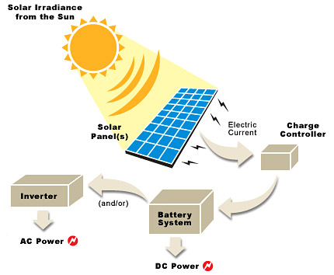

**Figure 1.** *Functional System Diagram*

# Introduction

As our world becomes more reliant on technology it is important to have sources of power to supply to our devices in a time of crisis. Texas more recently has experienced power outages during unexpected extreme winter conditions. Additionally, This system promotes the use of renewable energy which is rapidly becoming more popular in society. The solar/battery power system is a system built to convert solar power into usable DC or AC electricity that is capable of charging common electronic devices. This system will be able to switch between battery power and solar power to ensure constant power delivery, making the system work even when the sun is not present. The user of this device will be able to monitor the solar panel and battery outputs using a website and phone application. This device will be useful when electricity is not easily accessible.

## Background

The Earth’s temperature is steadily increasing, eventually making it too warm to grow crops, and increasing the risk of more frequent and heavier rainfall, snowfall, and other types of precipitation. A recent example of severe precipitation was the snowstorm in Texas on February 13th which caused 4.5 million homes to be without power, resulting in the worst energy infrastructure failure in history.

As a result, a need to switch from relying on fossil fuels to relying on renewable energy has emerged due to global warming and its effects. There are many types of renewable energy sources that are being used today to make the switch from fossil fuels. Harnessing energy from the sun, known as solar power, will be our focus for this project. Solar energy is one of the top three most popular renewable energy sources today since it is easy to install, predictable, requires little maintenance, and doesn't use power to operate.

Our team’s solar powered independent grid aims to showcase these advantages through solar energy’s reliability, effectiveness, and wide range of applications. This system will be able to monitor the sun for optimal power harnessing during peak sunlight hours and switch to battery power when interferences occur. With this architecture, the user will be able to charge their devices even when the sun is not out, providing cost effective alternatives to their current power sources.

## Overview

Our system will use a Maximum Power Point Tracking (MPPT) algorithm to continuously adjust the impedance seen by the solar array to keep the PV system operating at, or close to, the peak power point of the PV panel under varying conditions. This will optimize the power output of the solar panel so the battery can be charging while the user is charging their devices. If the PV panel is under varying conditions or there is no sunlight, the system will switch to battery power so the user’s devices will still receive power. Additionally, the algorithm will constantly send data to the backend database so that it can be stored and monitored using a website and android application. The purpose of the website and app is to funnel and display the data received from the solar panel such as a graph of the peak harnessing times throughout the day, the current power storage of the battery, maintenance of the solar panel, whether the battery is discharging or charging, and if there is devices connected to the system.

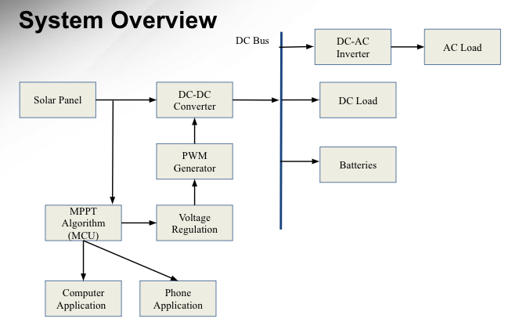

**Figure 2:** *Topology of Solar/Battery Power System*

# Operating Concept

## Scope

The solar/battery power system aims to provide a source of renewable energy, using solar energy to charge a laptop and a cell phone. The DC electricity generated by the solar panel flows through a DC-DC converter which acts to convert the variable input voltage (20-60 Vdc) to the desired output voltage (12 Vdc), while also charging a battery that will be used when not enough power is being produced by the solar panels. This ensures the charging of a device even when the sun is not present. A DC-AC inverter is used to convert the DC electricity (12Vdc) to AC electricity (110 Vac), allowing the use of the electrical grid. A MPPT algorithm will keep the PV system operating at the peak power point of the PV panel. The system will also constantly record and send data to the backend database, which will be displayed through a website and android app.

## Operational Description and Constraints

This power grid system is intended for consumers to store and generate consumer usable power, carrying the ability to use stored power in situations where adequate power is not generated from the solar panel. This data can be presented to the user through a website and app as stated above. Listed below are the constraints for this system.

* The budget for the solar/battery power system is $400.
* The system must be able to tolerate outdoor temperatures from -15 degC to 50 degC.
* Must be placed in light to generate power, stored power will only last so long.
* The solar/battery power system is not portable.
* The grid can only handle one load at a time.

## System Description

This solar power system will consist of four distinct subsystems; a max power point tracking system, a DC-DC converter, a DC-AC inverter, and a website/app. Detailed below is each subsystem and a short description of what they do and how they work.

* MPPT System - This subsystem regulates the power and voltage (PV) output between the solar panel and the battery. Specifically it will monitor the current and voltage output of the solar panel, battery, and DC-DC output. Additionally, this system will determine if the system will be supplied by the battery when the solar panel is not producing enough power.
* DC-DC Converter - This subsystem is dedicated to converting the input voltage to a desired output voltage. More specifically, the subsystem will draw altered voltage and current from the solar cells and decrease the voltage to 12V while increasing the current using a buck converter. Feedback will use the MPPT system to ensure a stable desired output voltage is achieved.
* DC-AC Inverter - The inverter acts to regulate the flow of electrical power. It switches the direction of direct current (DC) electricity, which the solar panel generates, back and forth very rapidly, hence converting it to alternating current (AC) electricity, which allows use of the electrical grid.
* Android Application and Website - This subsystem includes a backend database. This database will be created using google Firebase, which will also host the website. The android application and website will both use Ionic with angular, allowing for concurrent coding of the application and website. This subsystem will communicate with the ESP32 to receive data from the solar panel system. The data that is received and displayed includes the current and voltage from the solar panel, the harnessing pattern from the sun in Watts, if the system is in discharging or charging mode, the devices connected to the two outputs provided in the system, and the power level of the battery.
* Switch Control - This subsystem will control when the system will draw power from the solar cell or the battery. If the solar cell is not delivering sufficient power, this controller will switch the system such that power will be directly drawn from the battery.

## Modes of Operations

This power grid system will have two main modes of operation. The first of which is when the solar panel itself is generating enough energy to power the consumer devices connected to it. In this case, the MPPT will regulate the voltage and current to charge the battery with max efficiency. The MPPT system will send a voltage to the DC-DC converter which will determine how much the current will increase or decrease to maintain a steady 12V supply. This 12V supply will be used directly on the 12V DC load or be converted to AC power through the inverter to the load when the battery is fully charged.Throughout this process, relevant voltage, current, and power data will be collected and sent to a database/website where it can be viewed by consumers.

The second mode of operation is if the solar panel does not provide enough energy to power the loads, typically at night or on cloudy days. In this case, power is taken directly from the battery storage (12V) and converted to either 110V 60 Hz AC for AC devices or directly used for DC consumer devices. The same current, voltage, and power data collection occurs in this mode of operation as well, funneling into an app and website viewable by consumers.

## Users

Our product is marketed primarily towards consumers that have a need to generate their own power independently, or simply want to start using renewable energy for means of a cleaner environment. The system is user friendly and requires little outside involvement as the system maintains itself. The user can set the device out to charge and generate power, then simply connect a device. Most small consumer devices will be compatible with the system including laptops and phones.

## Support

A detailed user manual will be included with the system, providing information on how the system works, instructions for installation and usage, tips for maintenance, tolerances, and additional relevant information regarding the product. The manual will also provide a website in which users can track the voltage, current, and power generated by the system.

# Scenario(s)

***4.1. Charging Devices in Remote Locations***

The primary use of a solar/battery power system is to have access to electricity when there is limited access to electricity. Due to the large size of this device it can be used in remote locations where someone is stationary for a long amount of time. This device can also track the amount of power and voltage available to them, and track when the solar panels reach maximum capability. The system allows someone to charge their phone and laptop at the same time during the day as well as during the night.

***4.2. Easier Access to Renewable Energy***

The solar/battery power system is useful in any location given enough room for the solar panels to fit. This allows a person to generate their own energy within their home and connect many common household devices (within the specified range). The solar panels allow the battery to charge during the day, thus allowing for the use of the devices even with the absence of sunlight.

***4.3 Determining optimal solar panel positions***

The solar/battery power system can be used to determine the best location for solar panels. Homes and businesses, who may not be familiar with the sun's positioning, can measure and track how much power the solar panels produce everyday. This data will be easily accessible through both applications to make the most efficient use of the solar panels.

# Analysis

## Summary of Proposed Improvements

* The battery will be solar powered. Therefore, it will be a self sustaining system.
* The system will supply both an AC and DC source, allowing for the charge of small electronics including laptops, phones, etc.
* The output will change depending on the amount of light received by the solar panels.
* The battery will be charged when light is received by the solar panel and supply power when light is no longer detected.
* The website will display the voltage output of the solar panel throughout the day for the user to track the efficiency.

## Disadvantages and Limitations

There are some limitations in the design of the solar/battery system. These are listed below:

* Due to the given price range, the overall power output of the solar panel will be the main priority. This directly decreases the ability to purchase a more efficient solar panel that can produce the same output while being smaller in design.
* System can only charge with sufficient light levels.
* Power generated during sufficient light level hours will depend on how big the solar cell is.
* Battery power will only be able to run for a couple of hours due to budget constraints
* The output terminals will only have two different types of outlets.

## Alternatives

The solar/battery power system has some alternatives solutions, some are listed below:

* The solar/battery power system could instead switch to battery when there is no light instead of sufficient light. The trade off being that the system could absorb more power than it is producing under low light levels.
* The solar panel can be switched out for any type of generator as long as the voltage and current are reconfigured.
* A smartphone application is an alternative to the website/database.

## Impact

There are economic, environmental, social, and health impacts associated with the solar/battery power system as listed below:

* **Economic Impact:** The system uses solar power, therefore it would lessen the cost of electrical bills.
* **Environmental and Sustainability:** The system uses a renewable energy source therefore decreasing the use of oil/gas methods.
* **Social:** Easier access to using renewable energy because of the lower cost of only supplying power to small devices. It will provide a good starting point for communities that may not be able to afford a solar panel array to power a house.
* **Health and Safety:** Producing power using the solar/battery power system is clean unlike most traditional generators. Owning and operating one of these systems will help battle pollution, a major health concern in this day and age.

Solar/Battery Power System

Clement Ong

Tarik Dawson

Lauren Lugo

Nathan Gil

**Functional System Requirements**

REVISION – Draft

2 December 2022

Functional System Requirements

for

Solar/Battery Power System

Team <16>

Prepared by:

_____________________________

Author Date

Approved by:

____Nathan Gil_______12/4/2022__

Project Leader Date

_____________________________

John Lusher, P.E. Date

_____________________________

T/A Date

**Change Record**

| **Rev.** | **Date** | **Originator** | **Approvals** | **Description** |
| --- | --- | --- | --- | --- |
| **1** | October 2nd, 2022 | Pen-Hao Huang |  | Midterm Release |
| **2** | December 4th, 2022 | Pen-Hao Huang |  | Final Release |

**Table of Contents**

**Table of Contents** 3

**List of Tables** 5

[**No table of figures entries found.**](https://docs.google.com/document/d/1s3BxRQPUXpz8_8zUblvEg3eeZnPW3qNz/edit#heading=h.49x2ik5) 5

[**List of Figures**](https://docs.google.com/document/d/1s3BxRQPUXpz8_8zUblvEg3eeZnPW3qNz/edit#heading=h.2et92p0) 6

**1.** **Introduction** 7

1.1. Purpose and Scope 7

1.2. Responsibility and Change Authority 8

**2.** **Applicable and Reference Documents** 8

2.1. Applicable Documents 8

2.2. Reference Documents 8

2.3. Order of Precedence 8

**3.** **Requirements** 9

3.1. System Definition 9

3.2. Characteristics 11

3.2.1. Functional / Performance Requirements 11

3.2.1.1. Solar Panel Maximum Power Output 11

3.2.1.2. Range of Loads 11

3.2.1.3 Switch Check 11

3.2.1.4 AC output 11

3.2.1.5 Max Power Point Tracing 12

3.2.1.5 System Shut Off 12

3.2.2. Physical Characteristics 12

3.2.2.1. Mass 12

3.2.3. Electrical Characteristics 12

3.2.3.1. Inputs 12

3.2.3.1.1 Power Consumption 12

3.2.3.1.2 Input Voltage Level 12

3.2.3.2. Outputs 12

3.2.3.2.1 Data Output 12

3.2.3.2.2 Diagnostic Output 13

3.2.4. Environmental Requirements 13

3.2.4.1. Pressure (Altitude) 13

3.2.4.2. Thermal 13

3.2.4.4. Rain 13

3.2.4.5. Humidity

3.2.5. Website and Application Requirements 13

3.2.5.1. Database Operations 14

3.2.5.2. Application and Website Post Request 14

3.2.5.3. System Display of Crucial Data 14

3.2.5.4. Physical Requirement 14

3.2.5.5 User Authentication 14

3.2.5.6 Existing User Authentication 14

3.2.6. DC-DC Converter Requirements 15

3.2.6.1 DC-DC Converter Feedback 15

3.2.6.2 DC-DC Converter Load Current Validation 15

3.2.6.3 DC-DC Converter Input Range Validation 15

3.2.6.4 DC-DC Converter Efficiency Validation 15

**4.** **Support Requirements** 15

4.1. Environmental Requirements 15

4.2. Local Wifi Access 15

4.3. Maintenance 16

**Appendix A Acronyms and Abbreviations 1****6**

**Appendix B Definition of Terms 1****7**

**List of Tables**

**Table 1: Subsystem Leads…..…………………………….……………………………………………….7**

**List of Figures**

**Figure 1: Topology of Solar Power Battery System……………………………………………….6**

**Figure 2: Block Diagram of System…………………………………………………………………….10**

The following definitions differentiate between requirements and other statements.

Shall: This is the only verb used for the binding requirements.

Should/May: These verbs are used for stating non-mandatory goals.

Will: This verb is used for stating facts or declaration of purpose.

# Introduction

## Purpose and Scope

The solar/power battery system is an accessible way to bring clean energy into homes. It can be used during power outages or for those living in rural areas. The design is to help those with basic knowledge of solar panels regulate and sustain their independent grid. The system will be able to charge common household electronics including laptops and phones. The user will be able to oversee the grid using an android phone application and a computer website. **Figure 1** below represents the system overview of the project in the proposed CONOPS document.



**Figure 1.** *Topology of Solar Power Battery System*

The system will be powered by solar power during the day, and then by a battery when the sun is no longer sufficiently providing energy. Current and voltage sensors will record the output of the solar panels, battery, and DC load. The Maximum Power Point Tracking (MPPT) will determine the optimal voltage and current to be set throughout the system based on the efficiency of the solar panel. All of the information collected will be transmitted through WiFi, which will then be uploaded to an online database. The system will display the trends and information of the day and present it on an android phone application and computer website.

## Responsibility and Change Authority

The team leader, Nathan Gil, has the responsibility of making sure that all requirements for the project are met. These requirements can only be changed through the approval of the team leader, and the approval of the sponsor Dr. Peng-Hao Huang.

| **Subsystem** | **Responsibility** |
| --- | --- |
| Microcontroller and MPPT | Lauren Lugo |
| DC to DC Converter | Tarik Dawson |
| DC to AC Inverter | Clement Ong |
| Phone and Computer Application | Nathan Gil |

**Table 1.** *Subsystem Leads*

# Applicable and Reference Documents

## Applicable Documents

The following documents, of the exact issue and revision shown, form a part of this specification to the extent specified herein:

| **Document Number** | **Revision/Release Date** | **Document Title** |
| --- | --- | --- |
| IEEE 307 | 1969 | IEEE Standard Definitions of Terms for Solar Cells |
| C2-2023 | 2023 | National Electrical Safety Code (R) |

## Reference Documents

The following documents are reference documents utilized in the development of this specification. These documents do not form a part of this specification and are not controlled by their reference herein.

| **Document Title** | **Publisher** |
| --- | --- |
| ESP32 WROOM Data Sheet | Espressif Systems |

## Order of Precedence

In the event of a conflict between the text of this specification and an applicable document cited herein, the text of this specification takes precedence without any exceptions.

All specifications, standards, exhibits, drawings or other documents that are invoked as “applicable” in this specification are incorporated as cited. All documents that are referred to within an applicable report are considered to be for guidance and information only, except ICDs that have their relevant documents considered to be incorporated as cited.

# Requirements

When we refer to the “Microcontroller and MPPT system” we are referring to a subsystem that is composed of a microcontroller, sensors, switches and the MPPT algorithm. This subsystem will monitor and regulate the outputs of the solar panel, DC-DC converter, and the battery. In doing so, the subsystem shall be able to determine if the solar panel should be in charging or discharging mode and the current and voltage of the solar panel after harnessing power from the sun. This subsystem shall then be able to send this data to the website and android application through a backend database. The “website and android application” refers to the user interface that the user will see when trying to evaluate the solar powered system. This system shall be able to retrieve data from the database and display it for the user for their convenience and analysis. The website will be accessible for anyone from anywhere as long as it has been paired up with their specific solar powered system. The android app shall operate in a timely manner for android users and display the information provided under the **Block Diagram of System** section. The “DC to DC converter” shall be able to convert 20V to 60V from the solar panel to 12V which can be used anywhere else in the system. This subsystem shall work accurately and accordingly to not harm a user's device. The “DC to AC inverter” is composed of an AC inverter and a PWM generator which shall alter the DC output of the solar panel into the appropriate AC signal needed for the AC output.

## System Definition

The solar/battery power system aims to provide a source of renewable energy, using solar energy to provide power to a laptop, cell phone, and various other consumer devices. The system will charge a battery while also providing an AC outlet as well as DC outlet to power any device connected to it. The solar/battery power system consists of 4 subsystems as shown in the figures below: Microcontroller and MPPT, DC-DC converter, DC-AC inverter, and the phone and computer application.



**Figure 2.** *Block Diagram of System*

The microcontroller/MPPT subsystem shall use current and voltage sensors to determine the best way to regulate the system by decreasing or increasing the current. Specifically, it will send an adjusted voltage signal to the DC-DC converter to output a corrected voltage and current. This will be done through the microcontroller which shall use Maximum Power Point Tracking (MPPT) to optimize the output to the loads. Additionally, this subsystem will use the microcontroller to determine which switches should be opened and closed. For example, when the solar panel is not producing enough power the solar panel switch shall open and we shall check if the battery is charged and close the switch between the load and the battery. All data from the sensors shall be sent over wifi to the database used for the android application and website subsystem.

The DC-DC buck converter subsystem shall take the variable output voltage of the solar panel from 20V to 60V and convert it to a stable 12VDC for use directly, or in other systems. The result of this allows the buck converter to output 12V no matter the input voltage (no matter the time of day) The output voltage can be changed by increasing the feedback voltage coming from the MPPT system. Increasing this voltage will cause the output voltage to lower and thereby allowing the MPPT to control the output of the system. In the case that the solar panel provides less than 12V, the microcontroller shall switch the system to use battery power. Both the input and output of this subsystem is monitored via the voltage/current sensors, which in turn, feed back into the microcontroller to be displayed through the application.

The DC-AC inverter subsystem will take in 12VDC from the DC-DC converter subsystem and convert it into 12VAC which allows for the use of the electrical grid. It will be made up of an MCU that will produce PWM, an H-bridge, and other basic elements used in electronic circuits. A step-up transformer will also be used to step-up the 12VAC to 165VAC peak-to-peak, hence producing enough power to efficiently charge the intended electronic device. A voltage and current sensor will monitor the output of the inverter for the purpose of data collection which will be displayed through the user interface application.

Android Application and Website will both use Firebase as a backend database to organize and fetch data that is received from the ESP32. Both applications shall consist of a user authentication page to provide security for user data, both applications, and database. This authentication shall consist of password, username, existing user, and new user checking. Once logged in, the data displayed consist of the power harnessed from the sun for that specific day, the max power output for a given day, the current, voltage, and power from inside the system, whether or not the system is charging devices using solar power or battery power, the battery level, and the devices that are connected. There shall be data on a weekly and monthly basis consisting of power, current, and voltage for the solar battery system as well. Both of these applications will be created using Ionic with Angular. These two softwares allows the user to create an app and website concurrently.

Overall, the system gathers energy from the solar panel, then either stores it in a battery or powers the consumer electronics connected to it. Every node will be tracked and delivered to the Phone and Computer application where it can be viewed for either maintenance or leisure purposes.

## Characteristics

### Functional / Performance Requirements

#### **Solar Panel Maximum Power Output**

The Solar/Battery Power System shall function as intended on any and all solar panels that provide up to 260W max power output.

*Rationale: The Solar/battery power system was designed to operate using a 260W max power solar panel. Any solar panel that provides equal to or less than 260W shall be able to work with the Solar/battery power system.*

#### **Range of Loads**

The Solar/Battery Power System shall be able to power all consumer electronics that consume up to 100W either in DC or in AC.

*Rationale: This is a requirement specified by our customer due to constraints of their system in which the Solar/battery power system is integrating.*

### Switch Check

The Solar/Battery Power System shall switch to battery power if the solar panel is not producing enough power.

*Rationale: This is a requirement specified by our customer due to constraints of their system in which the Solar/battery power system is integrating.*

### AC Output

The Solar/Battery Power System shall output AC electricity that is identical to the United States power grid.

*Rationale: This is a requirement specified by our customer due to constraints of their system in which the Solar/battery power system is integrating.*

### Max Power Point Tracing

The Solar/Battery Power System shall be able to trace the maximum power point.

*Rationale: This is a requirement specified by our customer due to constraints of their system in which the Solar/battery power system is integrating.*

* + - 1. **System Shut Off**

The Solar/Battery Power System shall disconnect when not enough power is being supplied.

*Rationale: This is a requirement that ensures the safety of the system.*

### Physical Characteristics

#### **Mass**

The mass of the Solar/Battery Power System shall be less than or equal to 32 kilograms.

### Electrical Characteristics

#### **Inputs**

1. The presence or absence of any combination of the input signals in accordance with ICD specifications applied in any sequence shall not damage the Solar/Battery Power System, reduce its life expectancy, or cause any malfunction, either when the unit is powered or when it is not.
2. No sequence of command shall damage the Solar/Battery Power System, reduce its life expectancy, or cause any malfunction.

*Rationale: By design, shall limit the chance of damage or malfunction by user/technician error.*

##### Power Consumption

The maximum peak power of the system shall not exceed 260 watts.

*Rationale: This is a requirement specified by our customer due to constraints of their system in which the Solar/Battery Power System is integrating.*

##### Input Voltage Level

The input voltage level for the Solar/Battery Power System generated from the solar panels shall be +0 VDC to +60 VDC.

*Rationale: This is a requirement specified by our customer due to constraints of their system in which the Solar/battery power system is integrating.*

#### **Outputs**

##### Data Output

The Solar/Battery Power System shall include a website and an android application for users to view information and trends regarding the system.

*Rationale: The Solar/Battery Power information passes directly to the customer’s system.*

##### Diagnostic Output

The Solar/Battery Power System shall include a diagnostic interface for maintenance and data logging.

*Rationale: Provides the ability to control things for debugging manually and a way to view/download the node map with associated potential targets.*

### Environmental Requirements

The Solar/Battery Power System shall be designed to withstand and operate in the environments and laboratory tests specified in the following section.

*Rationale: This is a requirement specified by our customer due to constraints of their system in which the Solar/Battery Power System is integrating.*

#### **Thermal**

The Solar/Battery Power System shall be able to tolerate outdoor temperatures ranging from -15 °C to 50 °C.

*Rationale: The minimum temperature in Bryan, Texas can reach -5 °C and the maximum temperature can reach 40 °C.*

#### **Rain**

The Solar/Battery Power System shall be able to function properly in an environment where rain is present.

#### **Humidity**

The Solar/Battery Power System shall be able to function properly in an environment with humidity levels ranging from 0% to 100%.

*Rationale: This is a requirement specified by our customer due to constraints of their system in which the Search and Rescue System is integrating.*

### Website and Android Application Requirements

The website and Android application shall use firebase backend database to pull information from the solar battery system (ESP-32). This data shall be pulled from firebase and displayed onto the website and Android application for the user.

*Rationale: This is a requirement specified by our customer due to constraints of their system in which the Solar/Battery Power System is integrating.*

#### **Database Operations**

The firebase backend database shall successfully gather and categorize data from the solar battery system, specifically the ESP-32 while wifi is provided.

*Rationale: In order to display data on the website and android application dynamically, they both shall pull this data to be displayed.*

#### **Website and Application Pull Request**

The website and application shall successfully pull data from the firebase database without interruption.

*Rationale: In order to display data on the website and android application dynamically, they both shall pull data successfully to be displayed.*

#### **System Display of Crucial Data**

The website and application shall display accurate data dynamically to the user for that day, week, and month.

*Rationale: This is a requirement specified by our customer due to constraints of their system in which the Solar/Battery Power System is integrating.*

#### **Physical Requirements**

The website and application shall be displayed properly on an android display and shall be functional in all aspects as listed by the sponsor.

*Rationale: This is a requirement specified by our customer due to constraints of their system in which the Solar/Battery Power System is integrating.*

#### **User Authentication**

The website and application shall allow the user to create a new account as long as the password exceeds six characters, the email is a valid email address, and there is not a user with the same username as the one that is being created.

*Rationale: This is a requirement so only users that have been authenticated can receive and write data to the backend database.*

#### **Existing User Authentication**

The website and application shall check if there is a user that exist with the email used to sign-in and if the password is correct

*Rationale: This is a requirement so only users that have been authenticated can receive and write data to the backend database.*

**3.2.6 DC-DC converter Requirements**

The DC-DC converter shall convert 20V-60V variable DC input into 12V DC output

*Rationale: The subsystem must be able to reliably power the other systems*

**3.2.6.1 DC-DC converter Feedback validation**

The DC-DC converter shall have a feedback network such that the MPPT system can control or lower the output voltage.

*Rationale: In order to charge a battery, voltage will need to be able to be changed.*

**3.2.6.2 DC-DC Converter Load Current Validation**

The DC-DC converter shall have the ability to supply 0 amps up to 20 amps as the rest of the system.

*Rationale: In order to power multiple 100W devices, at least 200 watts are required. Ensuring 20 amps can be supplied will cover up to 240 watts consumed.*

**3.2.6.3 DC-DC Input Range Validation**

The DC-DC converter shall function as intended with input ranging from 20V DC to 60V DC.

*Rationale: The input is a solar panel whose output is 0V to 60V*

**3.2.6.4 DC-DC Converter Efficiency Validation**

The DC-DC converter shall be at the least above 60%

*Rationale: Converter must be able to transfer power efficiently*

# Support Requirements

#### **Computer or Smartphone with Internet Access**

The website will be hosted using firebase, which has to be accessed through the internet. The app can only be downloaded and connected with internet access. To view the data that is displayed on the website and android application, the user must meet this requirement.

*Rationale: Other forms of accessibility to this system are outside the scope of this project.*

#### **Local Wifi Access**

In order to view the data from the system, the system needs to have access to WiFi so that the ESP32 can communicate with the backend database.

*Rationale: This is the means for the system to communicate with the backend database.*

#### **Maintenance**

The user shall check the website and application daily to ensure proper use and operation of the system.

*Rationale: Environmental factors may inhibit power harnessing, the user shall be able to access and clean solar panels if necessary.*

# Appendix A: Acronyms and Abbreviations

MPPT Maximum Power Point Tracking

MCU Microcontroller Unit

VDC Volts of Direct Current

VAC Volts of Alternating Current

W Watts

°C Degrees Celsius

UV Ultraviolet

PWM Pulse Width Modulator

# Appendix B: Definition of Terms

Solar/Battery Power System

Clement Ong

Tarik Dawson

Lauren Lugo

Nathan Gil

**Interface Control Document**

REVISION – Draft

2 December 2022

Interface Control Document

for

Solar/Battery Power System

Team <16>

Prepared by:

_____________________________

Author Date

Approved by:

____Nathan Gil_______12/04/2022__

Project Leader Date

_____________________________

John Lusher II, P.E. Date

_____________________________

T/A Date

**Change Record**

| **Rev.** | **Date** | **Originator** | **Approvals** | **Description** |
| --- | --- | --- | --- | --- |
| **0** | October 2nd, 2022 | Pen-Hao Huang |  | Midterm Release |
| **1** | December 4th, 2022 | Pen-Hao Huang |  | Final Release |

**Table of Contents**

**Table of Contents** 3

**List of Tables** 4

**List of Figures** 5

**1.** **Overview** 6

**2.** **References and Definitions** 6

2.1. References 6

2.2. Definitions 6

**3.** **Physical Interface** 6

3.1. Weight 6

3.2. Dimensions 7

3.2.1. Dimensions of the Solar/Battery Power System7

3.3. Mounting 7

3.3.1. Placement of Solar/Battery System7

**4.** **Thermal Interface** 7

[4.1.](https://docs.google.com/document/d/1oE2DfG66k3oLzQfO3jbMR8eg0nUGLV6A/edit#heading=h.4i7ojhp) Thermal Shielding of Microcontroller 7

4.2. Cooling of Battery 7

**5.** **Electrical Interface** 8

5.1. Primary Input Power 8

5.1.1 Microcontroller 8

5.2. Voltage and Current Levels 8

5.2.1 Maximum Values 8

5.3. Signal Interfaces 9

5.4. User Control Interface 9

**6**. **Communications / Device Interface Protocols 9**

6.1. Wireless Communication (Wifi) 9

**List of Tables**

**Table 1: Solar Panel System Weight Specifications……………………………………………..6**

**Table 2: Solar Panel System Dimension Specifications…………….…………………………..7**

**Table 3: Maximum Voltage and Current Levels….………………………………………………..8**

**List of Figures**

**Figure 1: Block Diagram of System…………………….……………………………………………….8**

# Overview

This document provides more detail on how the subsystems will interface together to achieve the system’s goals. It will list all of the dimensions, weights, inputs, and outputs descriptions. It will describe the interaction between the current and voltage sensors and the microcontroller (MCU), as well as the communication through WiFi between the microcontroller and the android app / computer website database.

# References and Definitions

## References

# IEEE 802.11

# Standard for Wi-Fi Networks

## Definitions

MCU Microcontroller Unit

VME VERSA-Module Europa

TBD To Be Determined

DC Direct Current

AC Alternating Current

# Physical Interface

## Weight

* + 1. **Weight of the Solar/Battery Power System**

The entire Solar/battery power system, including the solar panels, will weigh no more than 70 pounds This allows one or two people to easily move the solar/battery power system into a desired location. The weight also ensures the system’s durability and stability after being mounted. **Table 1** below shows the weight of each component.

| **Component** | **Weight** |
| --- | --- |
| Solar Panel | Est. 60 lbs |
| DC-DC Buck Converter | TBD |
| DC-AC Inverter | TBD |
| Microcontroller | TBD |
| Battery | TBD |

**Table 1.** *Solar/Battery Power System Weight Specifications*

## Dimensions

* + 1. **Dimensions of the Solar/Battery Power System**

The Solar panel and battery will stand alone, but the other subsystems will fit into a 1ft by 1ft box to provide protection against outside factors. **Table 2** below shows the dimensions of the components.

| **Component** | **Length** | **Width** | **Height** |
| --- | --- | --- | --- |
| Solar Panel | Est. 5’8” | Est. 3.5’ | 6” |
| DC-DC Converter | TBD | TBD | TBD |
| DC-AC inverter | TBD | TBD | TBD |
| Microcontroller | TBD | TBD | TBD |
| Battery | TBD | TBD | TBD |

**Table 2.** *Solar/Battery Power System Dimension Specifications*

## Mounting Locations

**3.3.1. Placement of Solar/Battery System**

The solar panel needs to be mounted in a location that faces the sun or has access to the sun for the majority of the day. This constraint allows for the system to be mounted onto the ground or even to a wall with a few tools. It is suggested to mount the system onto a falter surface to obtain optimal harnessing and operation.

# Thermal Interface

**4.1. Thermal Shielding of Microcontroller**

The microcontroller will be shielded from direct sunlight from within a box that shall be mounted onto the solar panel. This architecture, along with an internal fan, will secure the longevity of this device.

**4.2. Cooling of Battery**

The battery will be air cooled under the solar panel. The heat generated by the battery shall be able to dissipate on its own.

# Electrical Interface



**Figure 1.** *Block Diagram of Solar/Battery Power System*

## Primary Input Power

## Microcontroller

The system design is intended to be autonomous and self-powered; the microcontroller will be powered by a 12V battery which is charged by the solar panel. The amount of capacity will be determined by the amount of charge throughout the day to the battery and the usage of the loads.

## Voltage and Current Levels

* + 1. **Maximum Values**

| **Component** | **Voltage [V]** | **Current [A]** | **Power [W]** |
| --- | --- | --- | --- |
| ESP32 | 3.3 | 0.5 | 1.65 |
| Current Sensor | TBD | TBD | TBD |
| Battery | 12V | TBD | TBD |

**Table 3.** *Maximum Voltage and Current Levels*

The current being drawn by the other components is not significant. The values of the table above are per second for power consumption at max power usage.

## Signal Interfaces

The signals interfaces are the signals from the microcontroller to the DC to DC converter in the form of PWM, the frequency is to be determined. Additionally, The input to the microcontroller comes from the voltage and current sensors.

## User Control Interface

There will be two different user interfaces, an Android App and a Website. Both of these applications will display the same data from our system allowing the user to view the data being collected by the internal sensors in real time. Specifically, the data consist of the voltage, current, power, and power harnessed from the sun throughout the day.

# Communications / Device Interface Protocols

## Wireless Communications (WiFi)

The microcontroller has a built-in Wi-Fi module using the IEEE 802.11 g/b/n standards. This connection will be used to send sensor outputs to the user database.

Solar/Battery Power System

Clement Ong

Tarik Dawson

Lauren Lugo

Nathan Gil

**Validation Plan**

REVISION – Draft

1 December 2022

| Paragraph # | Test Name | Success Criteria | Paragraph # | Test Name | Success Criteria |
| --- | --- | --- | --- | --- | --- |
| 3.2.1.1 | Solar Panel Maximum Output | The Solar/battery power system functions when connected to a 220W source | Connect a 220W source to the solar/battery system and check node data | Not Tested | Clement Ong |
| 3.2.1.2 | Range of Loads | System can power a device consuming up to 100W | Plug a 100W load into either the DC or AC output. | Not Tested | Tarik Dawson |
| 3.2.1.3 | Switch Check | System will switch to battery power when the solar panel is not producing enough; system will open switch when solar panel is not producing; and the system will open the load switch when the battery is charging | Observe voltage output using voltage sensor (voltage divider), update status through MCU | Tested | Lauren Lugo |
| 3.2.1.4 | AC Output | AC output will be identical to standard US AC outlet power | Use a multimeter to test the AC output of the system | Not Tested | Clement Ong |
| 3.2.1.5 | Max Power Point Track | System can track the max power the solar panel can give the system | Track power through system, using voltage dividers and current sensors | Tested | Lauren Lugo |
| 3.2.1.6 | System Shut Off | System disconnects when not enough power is being supplied | Disconnect all inputs and ensure all switches receive no power | Tested | Lauren Lugo |
| 3.2.2.1 | Mass | System will be no heavier than 32 kilograms | Weigh the whole system with the solar panel included | Tested | Tarik Dawson |
| 3.2.3.1.1 | Power Consumption | The system will not consume more than 260W | allow the system to charge with no load, if the battery charges at all, success criteria is fulfilled | Tested | Lauren Lugo |
| 3.2.3.1.2 | Input Voltage | System works with input voltage from 20V to 60V | Connect load to the system in complete darkness and when the solar panel produces max voltage | Not Tested | Tarik Dawson |
| 3.2.3.2.1 | Data Output | The website/application subsystem is receiving data | Run the system normally. If the website is getting data, success criteria is fulfilled | Tested | Nathan Gil |
| 3.2.3.2.2 | Diagnostic Output | The website/application subsystem is receiving data dynamically | Run the system normally. If the website is getting internal data, success criteria is fulfilled | Tested | Nathan Gil |
| 3.2.4.1 | Thermal | System works in the temperature range of -15 to 50 degrees Celsius | Test system functionality at -15C and 50 using heating and cooling device | Not Tested | Nathan Gil |
| 3.2.4.2 | Rain | System works in the rain | Test system functionality in the rain | Not Tested | Tarik Dawson |
| 3.2.4.3 | Humidity | System works for all humidity levels | Test system functionality from 0% humidity to 100% in increments of 25 | Not Tested | Tarik Dawson |
| 3.2.5.1 | Database Operations | Firebase Backend Database successfully receives and categorizes data | Test database functionality by measuring voltage, power, etc. directly and matching it to database | Tested | Nathan Gil |
| 3.2.5.2 | Application and Website Post Request | Website and Application successfully pulls data from firebase backend database | Test by outputting to the local console of website and app to confirm correct data is being pull | Tested | Nathan Gil |
| 3.2.5.3 | System Display of Crucial Data | Application and Website provides correct data depending on day, week, and month | Compare display data to database, and physical components in real time (updates dynamically) | Tested | Nathan Gil |
| 3.2.5.4 | Physical Requirement | Website and Application works on android phone along with displaying properly | Test app and website on Android physical phone and interact with the applications | Tested | Nathan Gil |
| 3.2.5.5 | User Authentication | Website and App will check if a user exist and if the new username is already used | Test application and check firebase authentication database to see new user and current users | Tested | Nathan Gil |
| 3.2.5.6 | Existing User Authentication | Website and App will check if email is correct format, if user has right password | Test by creating a user, and trying to login with wrong password and try and make a fake email | Tested | Nathan Gil |
| N/A | Full system demo | System converts solar power to usable AC or DC power while charging a battery | Place a solar panel under the sun and check outputs on both the DC and AC terminals. | Not Tested | Full team |
| 3.2.6.1 | DC-DC Feedback Validation | DC-DC converter uses feedback from the MPPT to adjust output voltage | Vary the feedback voltage and observe if it has an effect on the output voltage | Tested | Tarik Dawson |
| 3.2.6.2 | DC-DC Load Current Validation | DC-DC converter supplies 12V up to 20 Amps | Attach the system to an Eload and test the system from 0 amps to 20 amps | Tested | Tarik Dawson |
| 3.2.6.3 | DC-DC Input Range Validation | DC-DC converter works as intended with an input of 20V to 60V | Vary the input from 20 to 60 volts using high current power supply and record the results | Tested | Tarik Dawson |
| 3.2.6.4 | DC-DC efficiency Validation | Efficiency is around 75% | Measure power input and power output, then calculate efficiency | Tested | Tarik Dawson |

Solar/Battery Power System

Clement Ong

Tarik Dawson

Lauren Lugo

Nathan Gil

**Schedule**

REVISION – Draft

1 December 2022

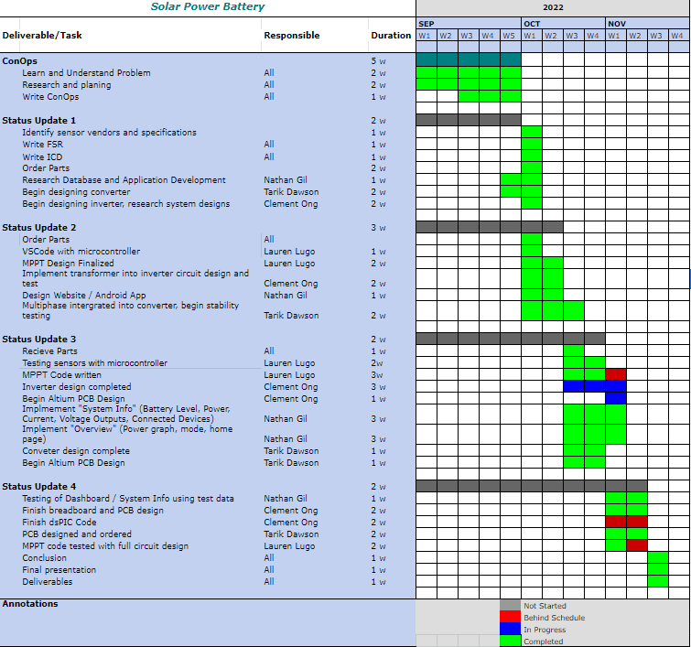

Solar/Battery Power System

Clement Ong

Tarik Dawson

Lauren Lugo

Nathan Gil

**Subsystem Reports**

REVISION – Draft

1 December 2022

Subsystems Report

for

Solar/Battery Power System

Team <16>

Prepared by:

_____________________________

Author Date

Approved by:

____Nathan Gil_______12/04/2022__

Project Leader Date

_____________________________

John Lusher II, P.E. Date

_____________________________

T/A Date

**Change Record**

| **Rev.** | **Date** | **Originator** | **Approvals** | **Description** |
| --- | --- | --- | --- | --- |
| **1** | December 4th, 2022 | Pen-Hao Huang |  | Final Report Release |

**Table of Contents**

**Table of Contents** 20

**List of Tables** 22

**List of Figures** 23

**1.** **Introduction** 25

**2.** **MPPT Subsystem** 25

2.1. Subsystem Introduction 25

2.2. MPPT Code 25

2.3. Current and Voltage Sensors 27

2.4. Switches and Output to DC-DC converter 28

**3.** **DC-DC Converter** 29

3.1. Subsystem Introduction 29

3.2. Subsystem Design 30

3.2.1 PCB Design 30

3.3. Subsystem Validation 31

3.3.1 Input Range Validation 32

3.3.2 Efficiency Validation 33

3.3.3 Load Current Validation 33

3.3.4 Feedback Validation 34

3.3.5 Oscilloscope Readings 35

3.4 Subsystem Diagnostic 38

3.5 Subsystem Solutions 38

3.6 Subsystem Conclusion38

**4.** **DC-AC Inverter** 38

4.1. Subsystem Introduction 38

4.2. Subsystem Design 39

4.2.1 Pulse Width Modulation 39

4.2.2 H-Bridge 42

4.2.3 Transformer 42

4.2.4 Simulation 42

4.2.5 PCB Design 44

4.3. Subsystem Validation 45

4.4 Subsystem Diagnostic 49

4.5 Subsystem Resolution/Mitigation 50

4.6 Subsystem Conclusion 50

**5.** **Android Application and Website** 50

5.1. Subsystem Introduction 51

5.2. Subsystem Design 52

5.3. Subsystem Validation 55

5.2.1. Data Output 55

5.2.2. Diagnostic Output 57

5.2.3. Database Operations 57

5.2.4. System Display of Crucial Data 59

5.3.5. User Authentication 59

5.3.6. Existing User Authentication 60

5.4. Subsystem Diagnostic 61

5.5. Subsystem Solution 61

5.5. Subsystem Conclusion 62

**List of Tables**

**Table 1: Subsystem Distribution…………………………………………………..……………………24**

**List of Figures**

**Figure 2.1: PCB Design of Microcontroller………....………………………….…………………..25**

**Figure 2.2: Flow Diagram of Sensor Response…....………………………….…………………..26**

**Figure 2.3:Monitor Response …………………………....………………………….…………………..29**

**Figure 2.4:MPPT Subsystem……………………………....………………………….…………………..29**

**Figure 3.1: Schematic of DC-DC Buck Converter...………………………….…………………..30**

**Figure 3.2: 1st Layer of DC-DC PCB………………………………………………..………….………..31**

**Figure 3.3: 2nd Layer of DC-DC PCB ...…………………………………………….…………………..31**

**Figure 3.4: System Input vs Output Voltage…………………………………..…………………..32**

**Figure 3.5: Zoom in of System Input vs Output Voltage………………….…………………..32**

**Figure 3.6: Efficiency vs Input Voltage………………………………………………………………..32**

**Figure 3.7: Output Current vs Output Current……………………………….…………………..33**

**Figure 3.8: Output Voltage vs Feedback Voltage………………………………………………..34**

**Figure 3.9: Input Voltage…………………………………………..……………………………………….35**

**Figure 3.10: Input Noise………………………………………………………………..…………………..36**

**Figure 3.11: Output Voltage.………………………………………………………….…………………..37**

**Figure 3.12: Output Noise.…………………………………………………………….…………………..37**

**Figure 4.1: DC-AC Inverter Schematic…………………………………………….…………………..39**

**Figure 4.2: dsPIC30F2010 Pinout…………………………………………………….…………………..39**

**Figure 4.3: Sine Table Plot……………………………………………………………..…………………..40**

**Figure 4.4. PWM Code………………………………………………………………………………………..41**

**Figure 4.5: H-Bridge Schematic……………………………………………………..…………………..42**

**Figure 4.6: Multisim Simulation…………………………………………………….…………………..43**

**Figure 4.7: PCB Design…………………………………………………………………..…………………..44**

**Figure 4.8: Inverter Breadboard…………………………………………………….………………….45**

**Figure 4.9: AD2 Wavegen Inputs………………………………………………………………………..45**

**Figure 4.10. Circuit Output Test 1 using AD2………………………………………………………46**

**Figure 4.11: Circuit Output Test 2 AD2…………….…………………………………………………46**

**Figure 4.12: H-Bridge Built on PerfBoard……………………………………………………………46**

**Figure 4.13: DC Power Supply…………………………………………………………………………….47**

**Figure 4.14: Inverter Circuit……………………………………………………………………………….47**

**Figure 4.15: MPLAB Output…………………………………………………..……………………………47**

**Figure 4.16: MCU Output from Oscilloscope……………………………………………………….48**

**Figure 4.17: Inverter Oscilloscope Output Test 1 using AD2………………………………..48**

**Figure 4.18: Inverter Oscilloscope Output Test 2 using AD2………………………………..48**

**Figure 4.19: Inverter Oscilloscope Output Test 3 using AD2………………………………..49**

**Figure 4.20. Timing Diagram from MOSFET Driver datasheet……………………………..49**

**Figure 5.1: Tree Structure Used in Firebase Database………………………………………..52**

**Figure 5.2: Initial Design of Website Application………………………………………………..53**

**Figure 5.3: Initial Design of Android Application………………………………………………..53**

**Figure 5.4: Final Design of Website Application………………………………………………….54**

**Figure 5.5: Final Design of Android Application………………………………………………….55**

**Figure 5.6: Applications Receiving Data from Firebase Database……………………….56**

**Figure 5.7: Testing Database from Applications…………………………………………………58**

**Figure 5.8: Database Receiving Data from Applications……………………………………..58**

**Figure 5.9: Authentication Showing Minimum Six Character Password Limit……..59**

**Figure 5.10: Authentication Page Showing Existing User Email Error………………….60**

**Figure 5.11: Authentication Page Showing Incorrect Password Error………………….60**

**Figure 5.12: Authentication Page Showing User Not Found Error……………………….61**

1. **Introduction**

The system will be powered by solar power during the day, and then by a battery when the sun is no longer sufficiently providing energy. Current and voltage sensors will record the output of the solar panels, battery, and DC load. The Maximum Power Point Tracking (MPPT) will determine the optimal voltage and current to be set throughout the system based on the efficiency of the solar panel. All of the information collected will be transmitted through WiFi, which will then be uploaded to an online database. The system will display the trends and information of the day and present it on an android phone application and computer website

| **Engineer Responsible** | **Subsystem** |
| --- | --- |
| Lauren Lugo | MPPT |
| Tarik Dawson | DC-DC Converter |
| Clement Ong | DC-AC Inverter |
| Nathan Gil | Android Application and Website |

Table 1: Subsystem Distribution

1. **MPPT**

***2.1 Subsystem Introduction***

The purpose of this subsystem is to maximize the output of the solar panel which is determined by the sensor's output. The microcontroller works between the other systems to bring them together cohesively. Each of the sensors and switches were tested individually to ensure that it performed as intended. Additionally, the system was tested together with the microcontroller to ensure the accurate and correct response to various combinations of inputs.

***2.2 MPPT Code***

***2.2.1 Operation***

The ESP32 Microcontroller has enough analog and digital pins and computation power to meet the requirements of the Solar/Battery Power System. It has twenty three analog/digital pins, two of which are also digital to analog output pins. This meets our needs as the subsystem consists of five sensors (analog input), one digital to analog converter output, and three switches (digital output). The ESP32 takes in a 3.3V -3.36V power supply which is supplied by the 12V battery using a voltage regulator. Additionally, there is a 3.3V supply voltage from the microcontroller which powers the switches.

This subsystem continuously reads inputs from all 5 sensors to maintain the logic communication with the switches. For example, when the solar power and battery both do not have enough power to supply to the loads the system goes into shut down mode resulting in all switches to open so there is no flow of current or voltage. The microcontroller is programmed to respond to these various scenarios to ensure proper operation.

A PCB has been designed to replace the ESP32 devkit currently used for prototyping. This will allow for the system to be easily integrated with the DC-DC converter and more secure connections.

**Figure 2.1: PCB design of Microcontroller**

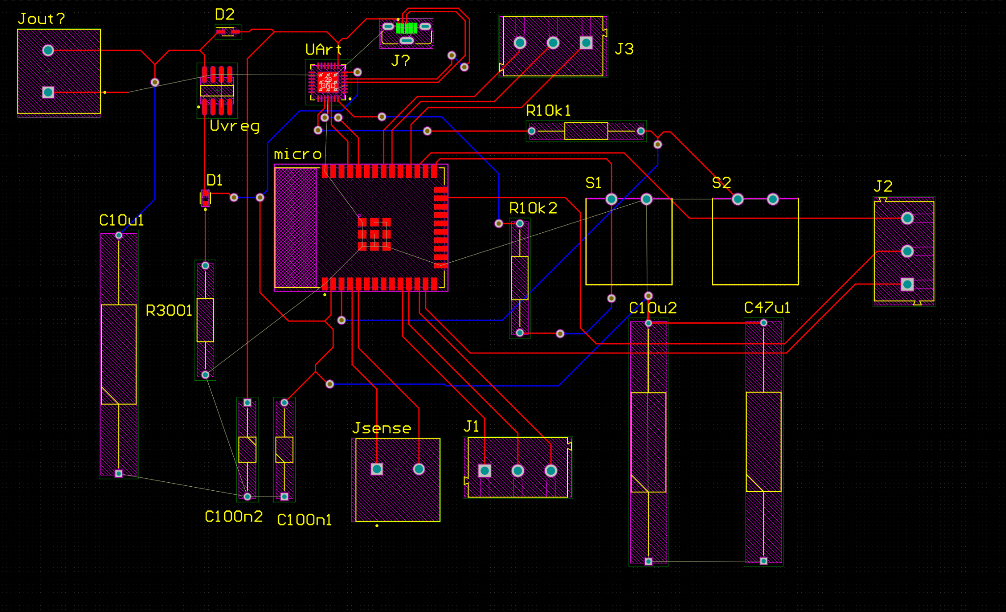

***2.2.2 Validation***

The MPPT Code was validated using various combinations of inputs to meet all the criteria. Its primary goal is to understand the state at which the system is in and process how the system can best maximize its power output. Figure 2.2 shows the logical operation of the response to sensor inputs.

**Figure 2.2: Flow Diagram of Sensor Response**



However, this diagram does not include the input of the sensors between the DC-DC converter to the load. These sensors were read as inputs but have yet to have specifications due to the lack of data from the DC-DC converter to understand the measurements.

***2.3 Current and Voltage Sensors***

**2.3.1 Operation**

The current and voltage sensors are the most critical to this subsystem because they are used to estimate the power from the solar panel. Maintaining the maximum power from the solar panel ensures that the Solar/Battery Power System works correctly, which requires accurate measurements of the output. Additionally, maintaining the battery supply is crucial in preparation for nightfall or cloudy weather when solar energy may be less prominent. The battery supply has only been measured by the voltage sensor for this system. The last two sensors are between the DC-DC converter and the DC load, to ensure the converter is outputting the expected amount.

To maintain these data points we used a voltage divider as our voltage sensor. We used a 10 milliohm resistor as our current sensor in combination with an op amp.

***2.3.2 Validation***

The sensors were divided into three circuits to be placed in their respective areas of measurement. Each pair was mounted on the same perfboard seen in Figure 2.4 on the left and above the microcontroller. Validation for these circuits was measured by the output using various inputs.

The circuit between the Solar Panel and the DC-DC converter was tested using up to 25 volts using a voltage supply and in connection with the solar panel up to 30 Volts. No higher measurement was taken due to the limit on the voltage supply. The circuit between the DC-DC Converter and the DC load was tested up to 12V, which is the expected output of the DC-DC Converter. Finally the circuit measuring the battery voltage was again tested using 12V. All final results were tested simultaneously with the microcontroller to ensure a proper input was produced. All sensors worked as expected.

***2.4 Switches and Output to DC-DC Converter***

**2.4.1 Operation**

The switches maintain the system and control the power flow to the various subsystems. The switches consist of a gate driver and a mosfet. The input is controlled by the microcontroller and the power supply comes from the 12V battery. The switches operate by receiving an enable signal from the microcontroller to close the switch or allow current/voltage. When the signal is high(3.3V) the switch is closed and when the signal is low(0V) the switch is open.

***2.4.2 Validation***

Similar to the sensors, various inputs were put into the switches to validate the design. Three of the switches were mounted on perfboards to validate and connect to the microcontroller. All three switches are all the same exact design but will be placed in different locations. The loads across the switches were tested for up to 25 volts which was the highest amount from our supply voltage. Additionally, the switches were tested with the microcontroller to ensure that the proper outputs were produced. All switches worked as expected, except for one.

***2.5 Subsystem Conclusion***

Overall, the subsystem worked as expected in regards to the inputs from the sensors and the outputs from the microcontroller. However, the current sensors have not been accurately calibrated in the microcontroller code to measure. Although the switch design does work, during the testing phase one of the switches was shorted due to faulty soldering. The design will still be used to create a PCB. The system does need to be tested with a 60V input at the solar power input. Overall, the system does need some adjustments but works as intended. The MPPT subsystem will play an essential role in controlling the whole system. The figure below shows how the whole system successfully works together.

**Figure 2.3: Monitor Response**

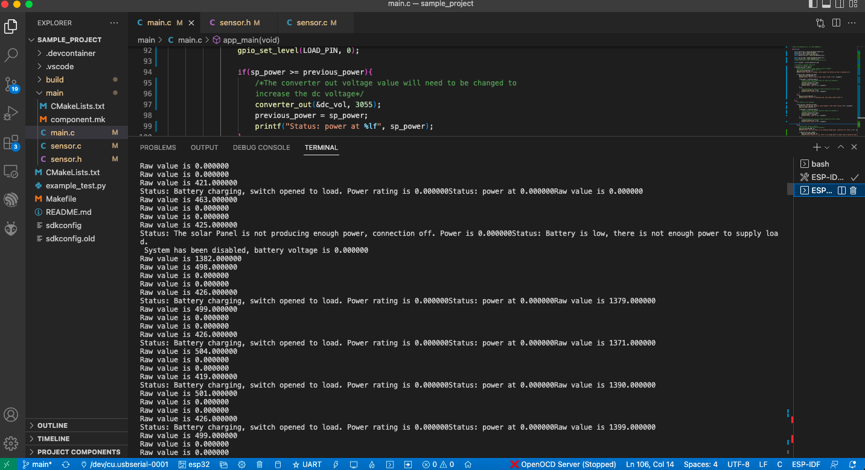

**Figure 2.4: MPPT Subsystem (3 sensors and 2 switches)**

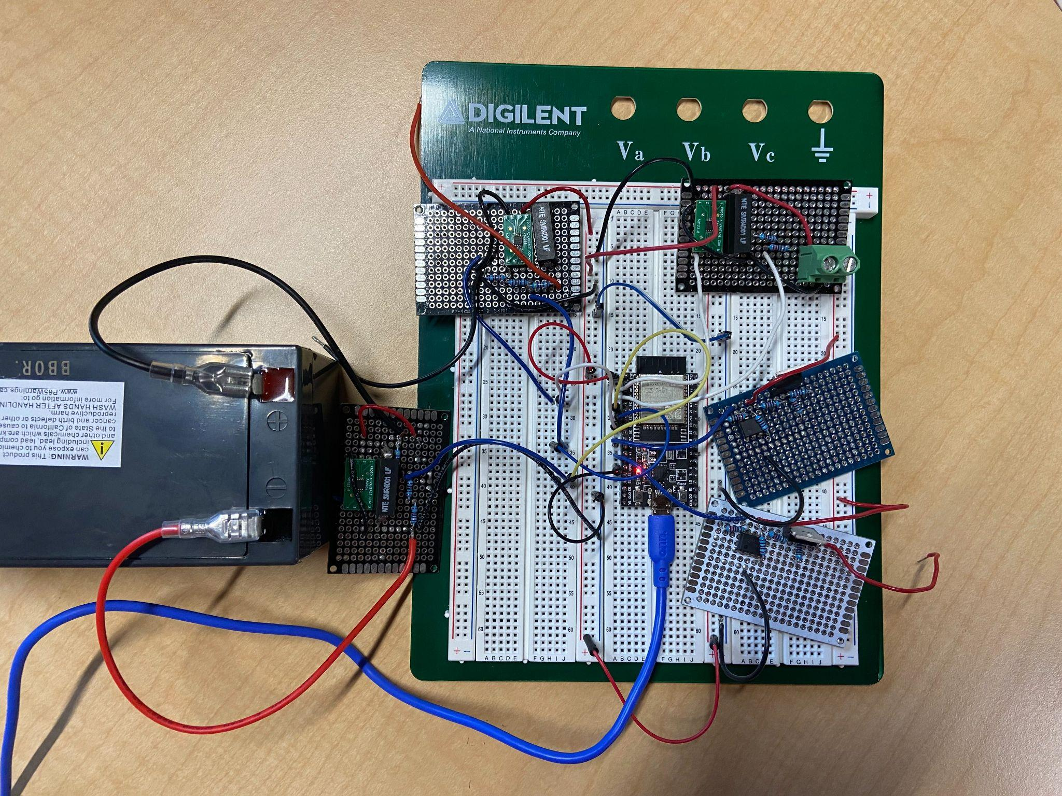

1. **DC-DC Converter**

***3.1. Subsystem Introduction***

This DC-DC converter subsystem is designed to take variable DC voltage from a solar panel and output 12V DC voltage by bucking or lowering the voltage while increasing the current. This converter was designed to be able to output as much as 20 amps of current while taking in up to 5 amps from the input. This output will supply power to the rest of the subsystem via a bus to either charge a battery, supply input power to the DC-AC converter, or supply an external DC load. The converter will also be able to change its output voltage via feedback from the MPPT subsystem. The subsystem was tested to ensure it functioned as expected.

***3.2. Subsystem Design***

The DC-DC converter subsystem will take 20V through 60V input DC voltage from a solar panel and output 12V DC voltage up to 20 amps. The system uses a LM5116 buck controller chip to control the gates of 2 MOSFETs to form a buck converter that outputs the desired value of 12 volts while taking in a feedback voltage to adjust the output voltage on command. Below is the schematic of the subsystem.

**Figure 3.1: Schematic of DC-DC Buck Converter**

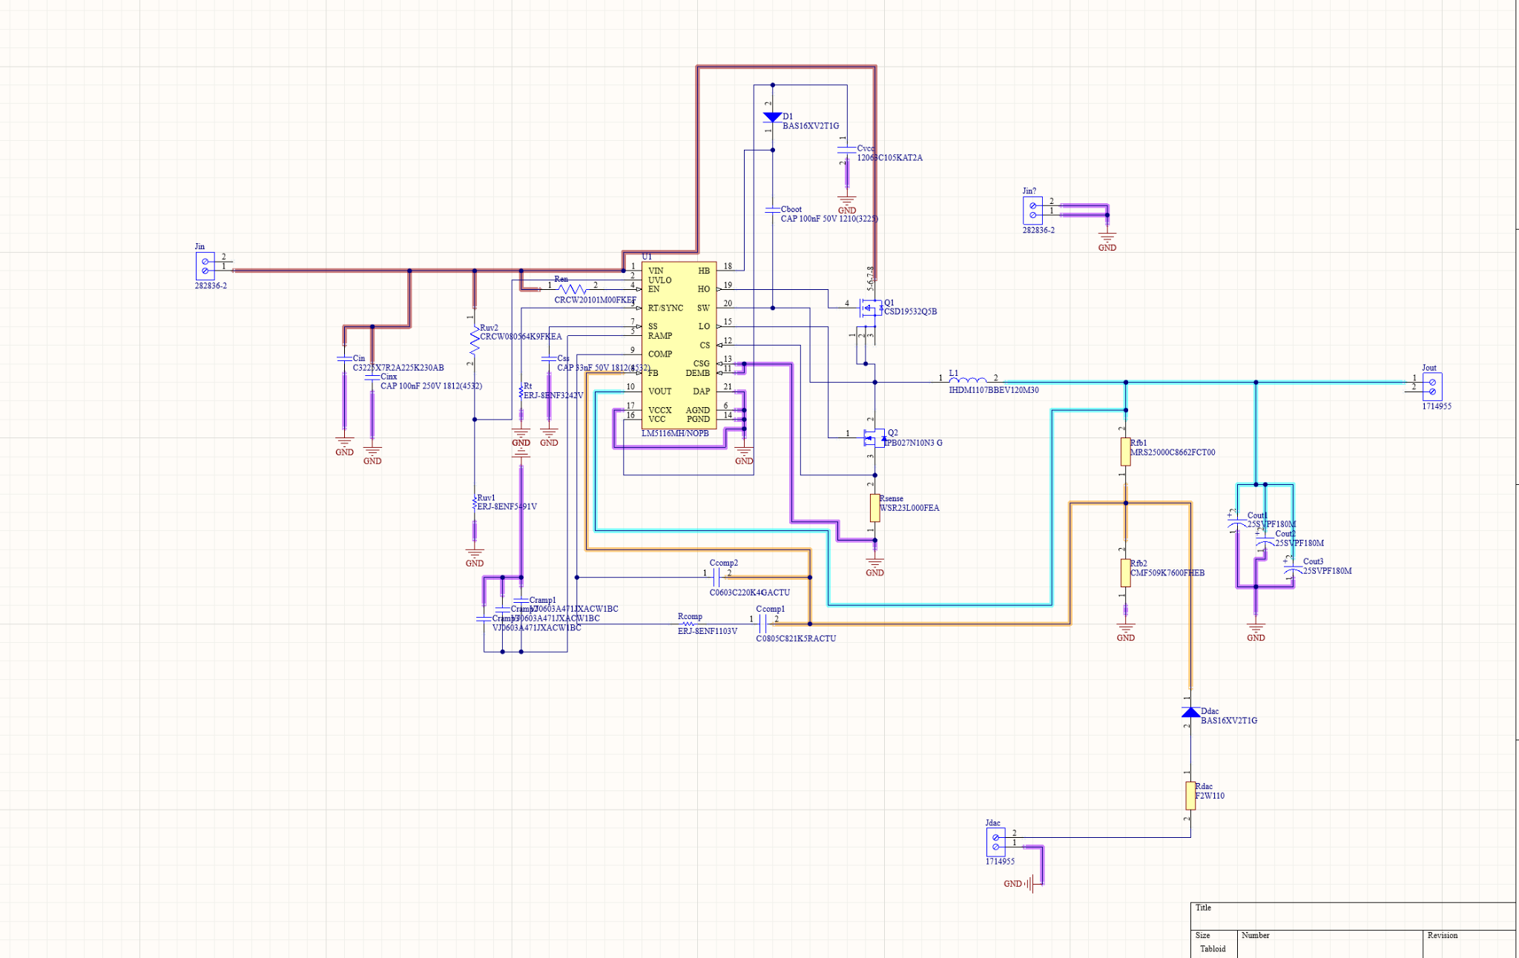

The primary challenge of the subsystem was ensuring that the converter and all of its parts could handle the high currents that flowed through it. This was accomplished by specifically ordering parts that were rated higher than the absolute max current and voltage this system could produce and by ensuring all traces were of sufficient width to ensure

***3.2.1. PCB Design***

The DC-DC converter subsystem was designed using Altium designer and is shown below.

This particular design consists of two layers, a top and bottom layer, along with terminal blocks for inputs, outputs and feedback.

**Figure 3.2: 1st layer of DC-DC PCB**

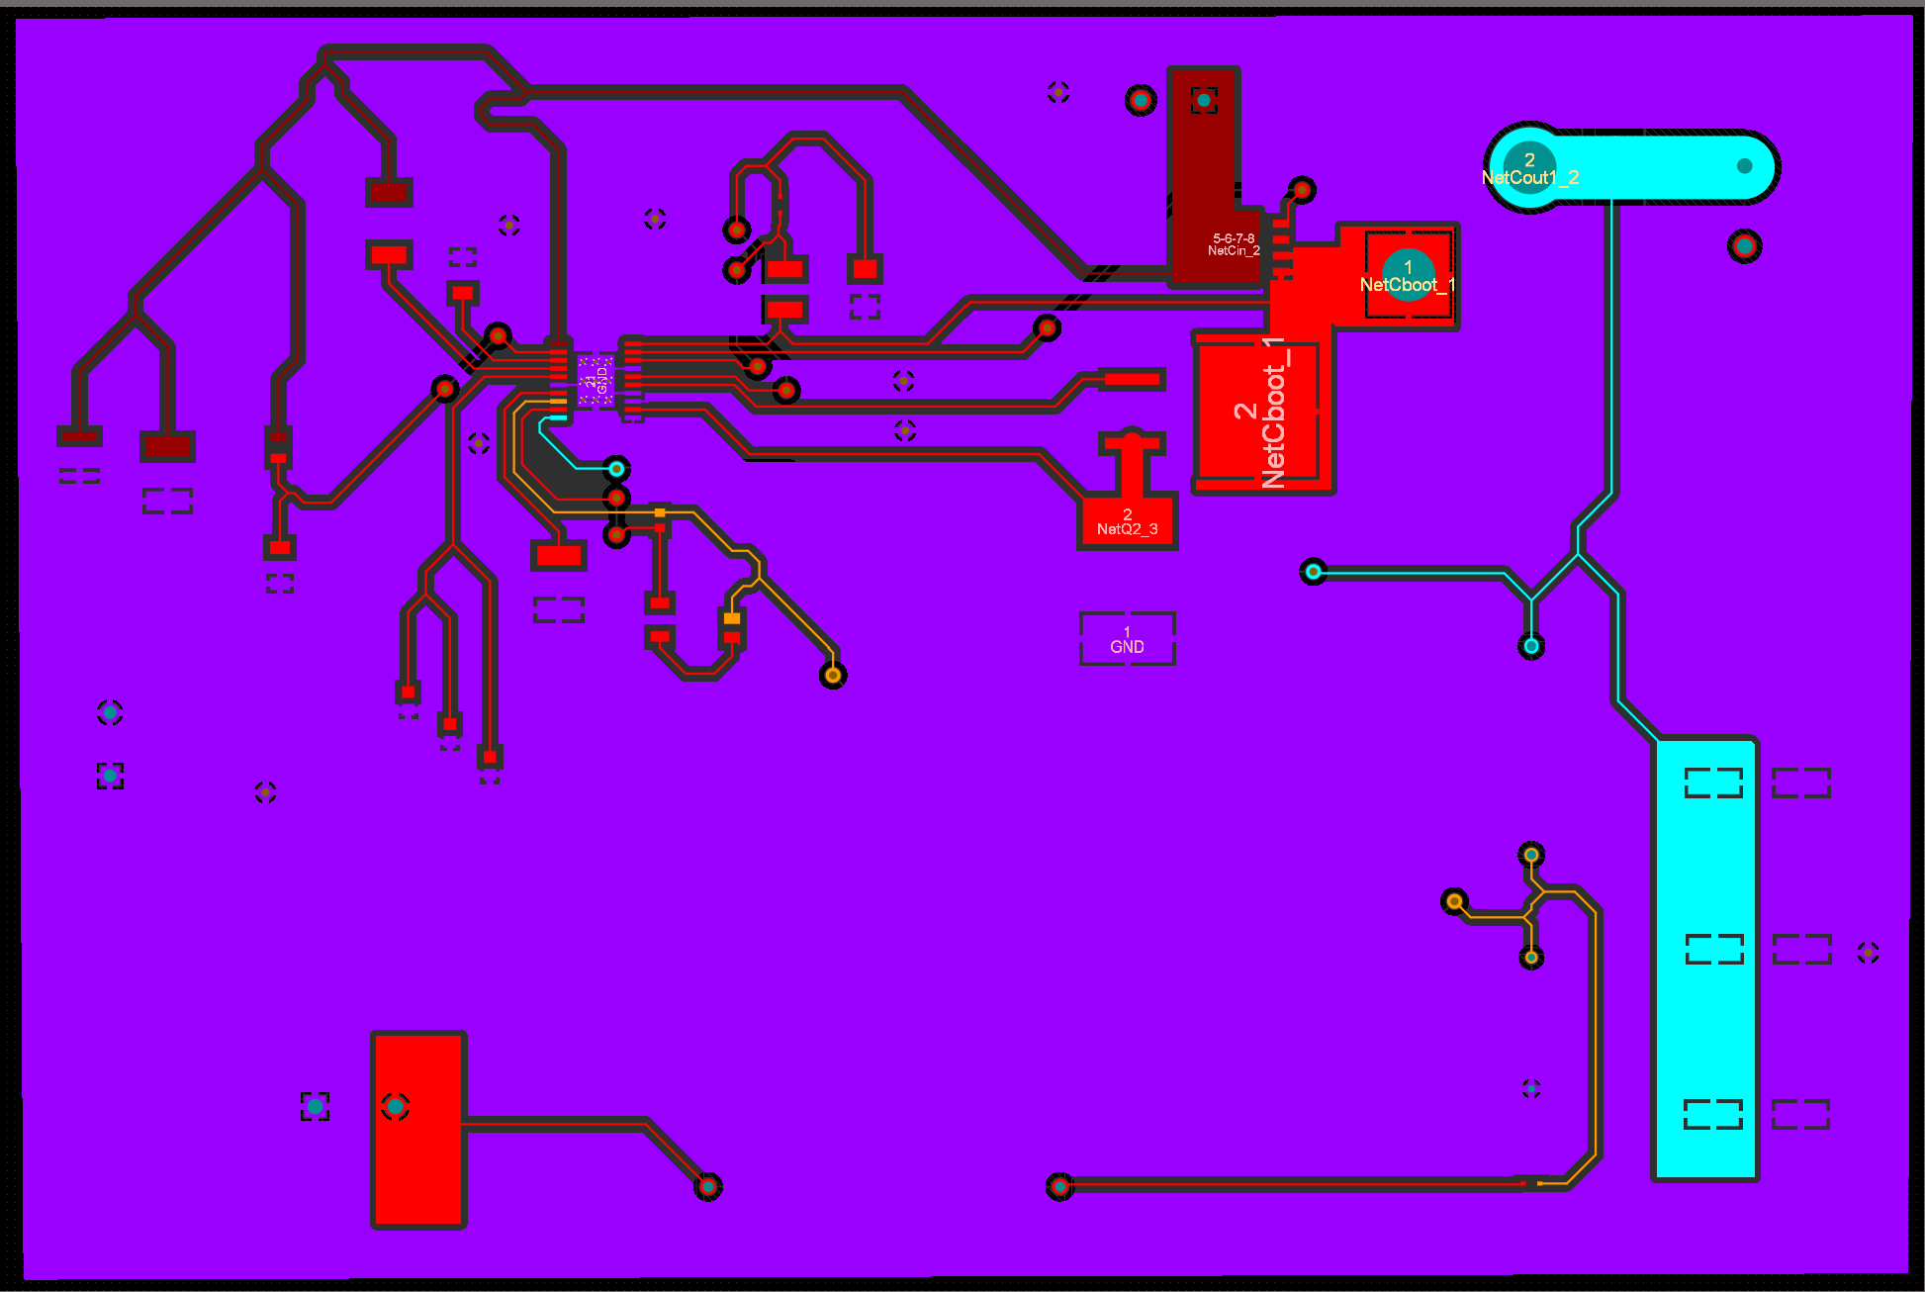

Above is the top layer of the DC-DC PCB and with all the traces and polygons in Altium.

**Figure 3.3: 2nd Layer of the DC-DC PCB**

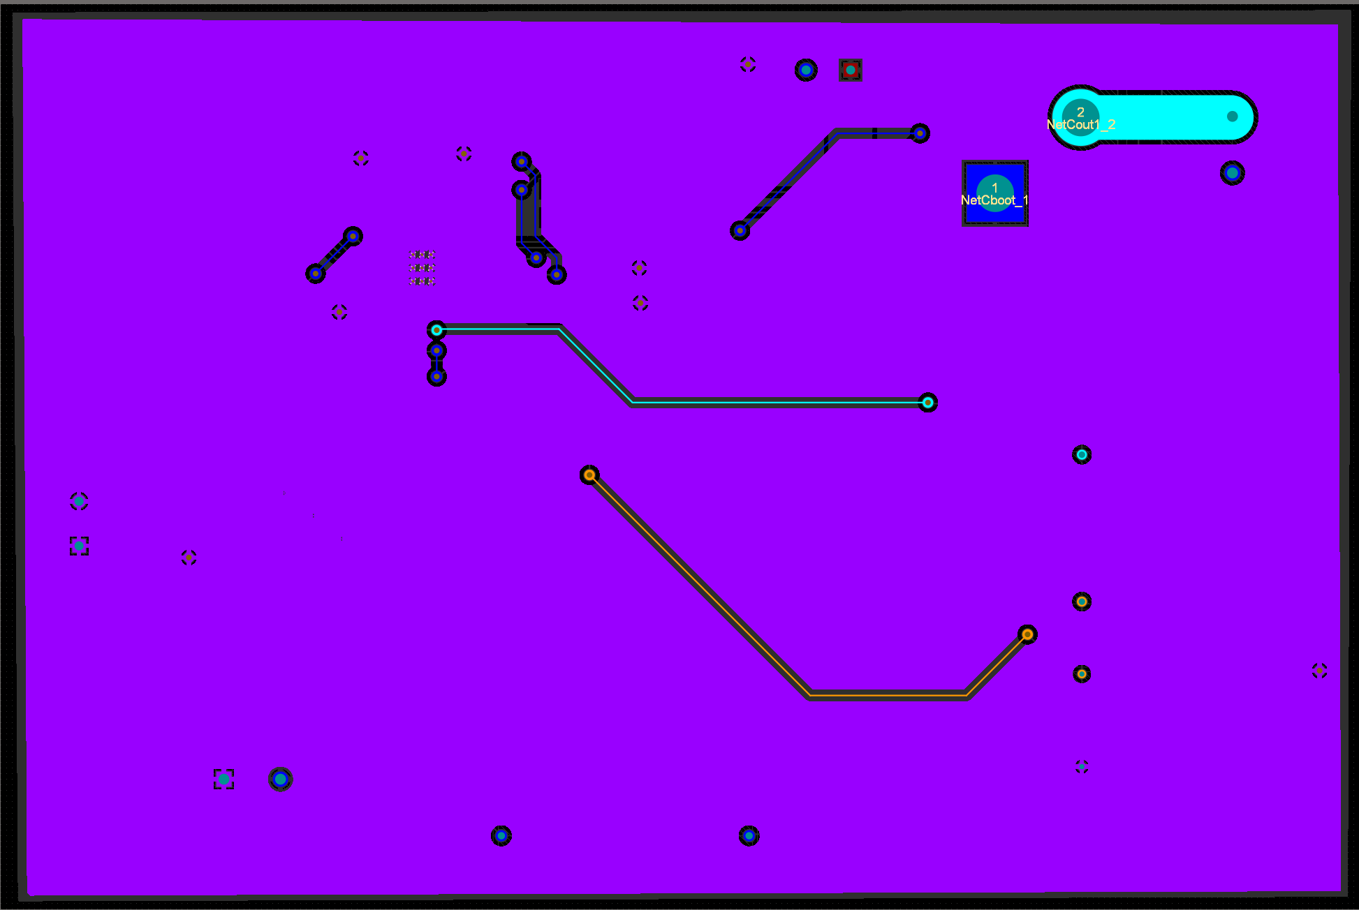

Above is the bottom layer of the DC-DC PCB and with all the traces and polygons in Altium.

***3.3. Subsystem Validation***

***3.3.1 Input range Validation***

This subsystem needs to be able to function as intended over all the possible input voltages. The first validation test for this subsystem was the variable input voltage test. This test was done by connecting the converter to a high power supply for input and an Eload in constant current mode set to 2.018 amps. Below is the result of that test.

***Figure 3.4: System Input vs Output voltage***

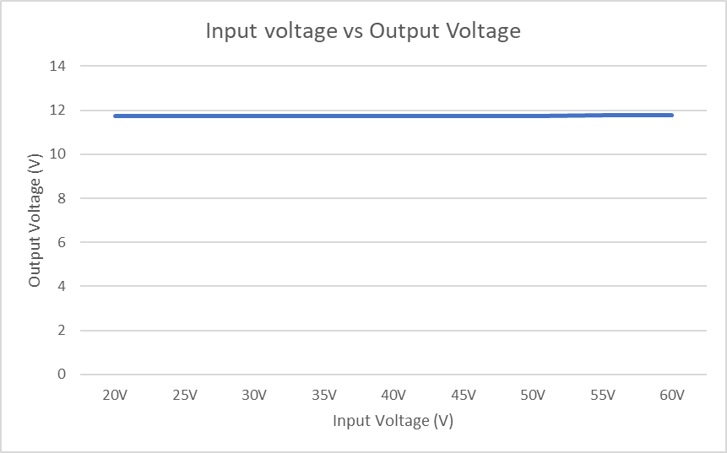

***Figure 3.5: Zoom in of System Input vs Output voltage***

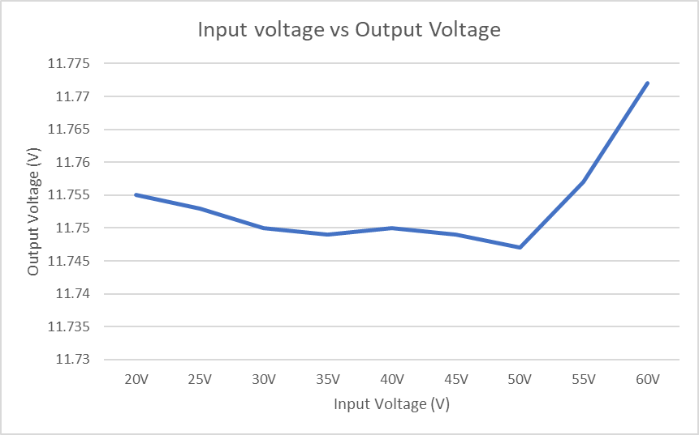

The data shows that the system outputs close to 12V DC output for varying inputs from 20V to 60V DC. This shows that the subsystem will be able to handle all input voltages from the solar panel.

***3.3.2 Efficiency Validation***

The subsystem must have a reasonable efficiency to work properly, there is no use for a converter that takes 200 watts and outputs 2 watts. Thus, a test was done to validate that the subsystem was efficient. Using data gathered from the variable voltage test, efficiency of the system was calculated to be around 80%.

***Figure 3.6: Efficiency vs Input Voltage***

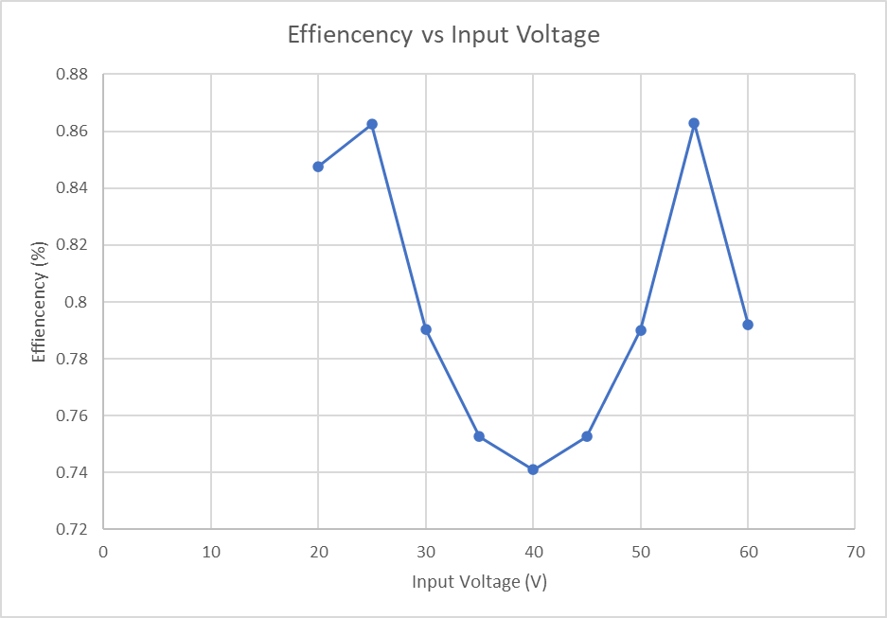

***3.3.3 Load Current Validation***

This subsystem must be able to power most loads that are attached to it. To confirm that the system will be able to accomplish this task, a validation test was conducted where the converter was supplied a constant voltage and was attached to an Eload to facilitate an increasing load. Below is the graph that shows how the system responds to various current loads from 0 amps to 15 amps.

***Figure 3.7: OutPut Voltage vs Output Current***

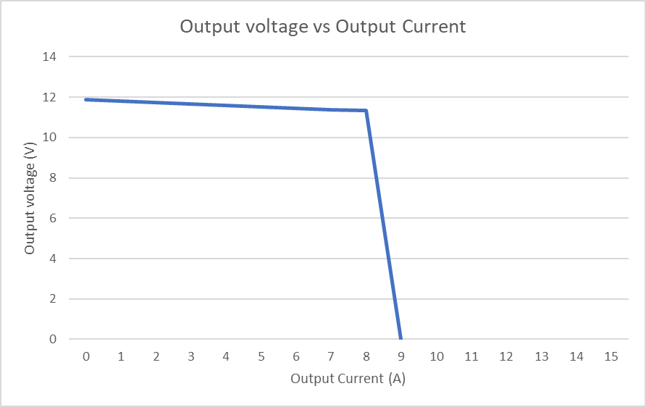

It should be noted that during the validation test, a trace started burning once the load current was set to 9 amps and the test was stopped. This is further discussed in the system diagnostics section.

***3.3.4 Feedback Validation***

This subsystem includes the ability to change the output voltage based on an input voltage taken from an external source. This was validated by performing a test in which the feedback voltage (input voltage from an external source) was varied from 1.2V to 4.7V. The input voltage was set to 45V and the load current was set to 1.5A using the Eload device.

***Figure 3.8: Output Voltage vs Feedback Voltage***

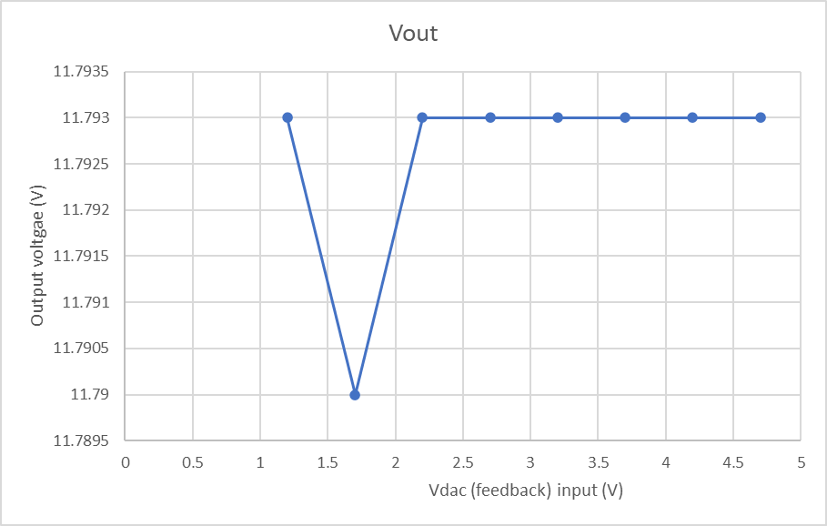

It should be noted that this portion of the system did not function as intended as there was no effect on the output voltage based on the range of input feedback voltages. This is further discussed in the system diagnostics section.

***3.3.5 Oscilloscope Readings***

Oscilloscope readings were taken to further understand what was happening to the system. The first reading was taken to understand the high current power supply. I believe that the large voltage swing that occurs at 0 secs is due to the power supply. All of these readings were taken with a current load of 2 amps.

***Figure 3.9: Input Voltage***

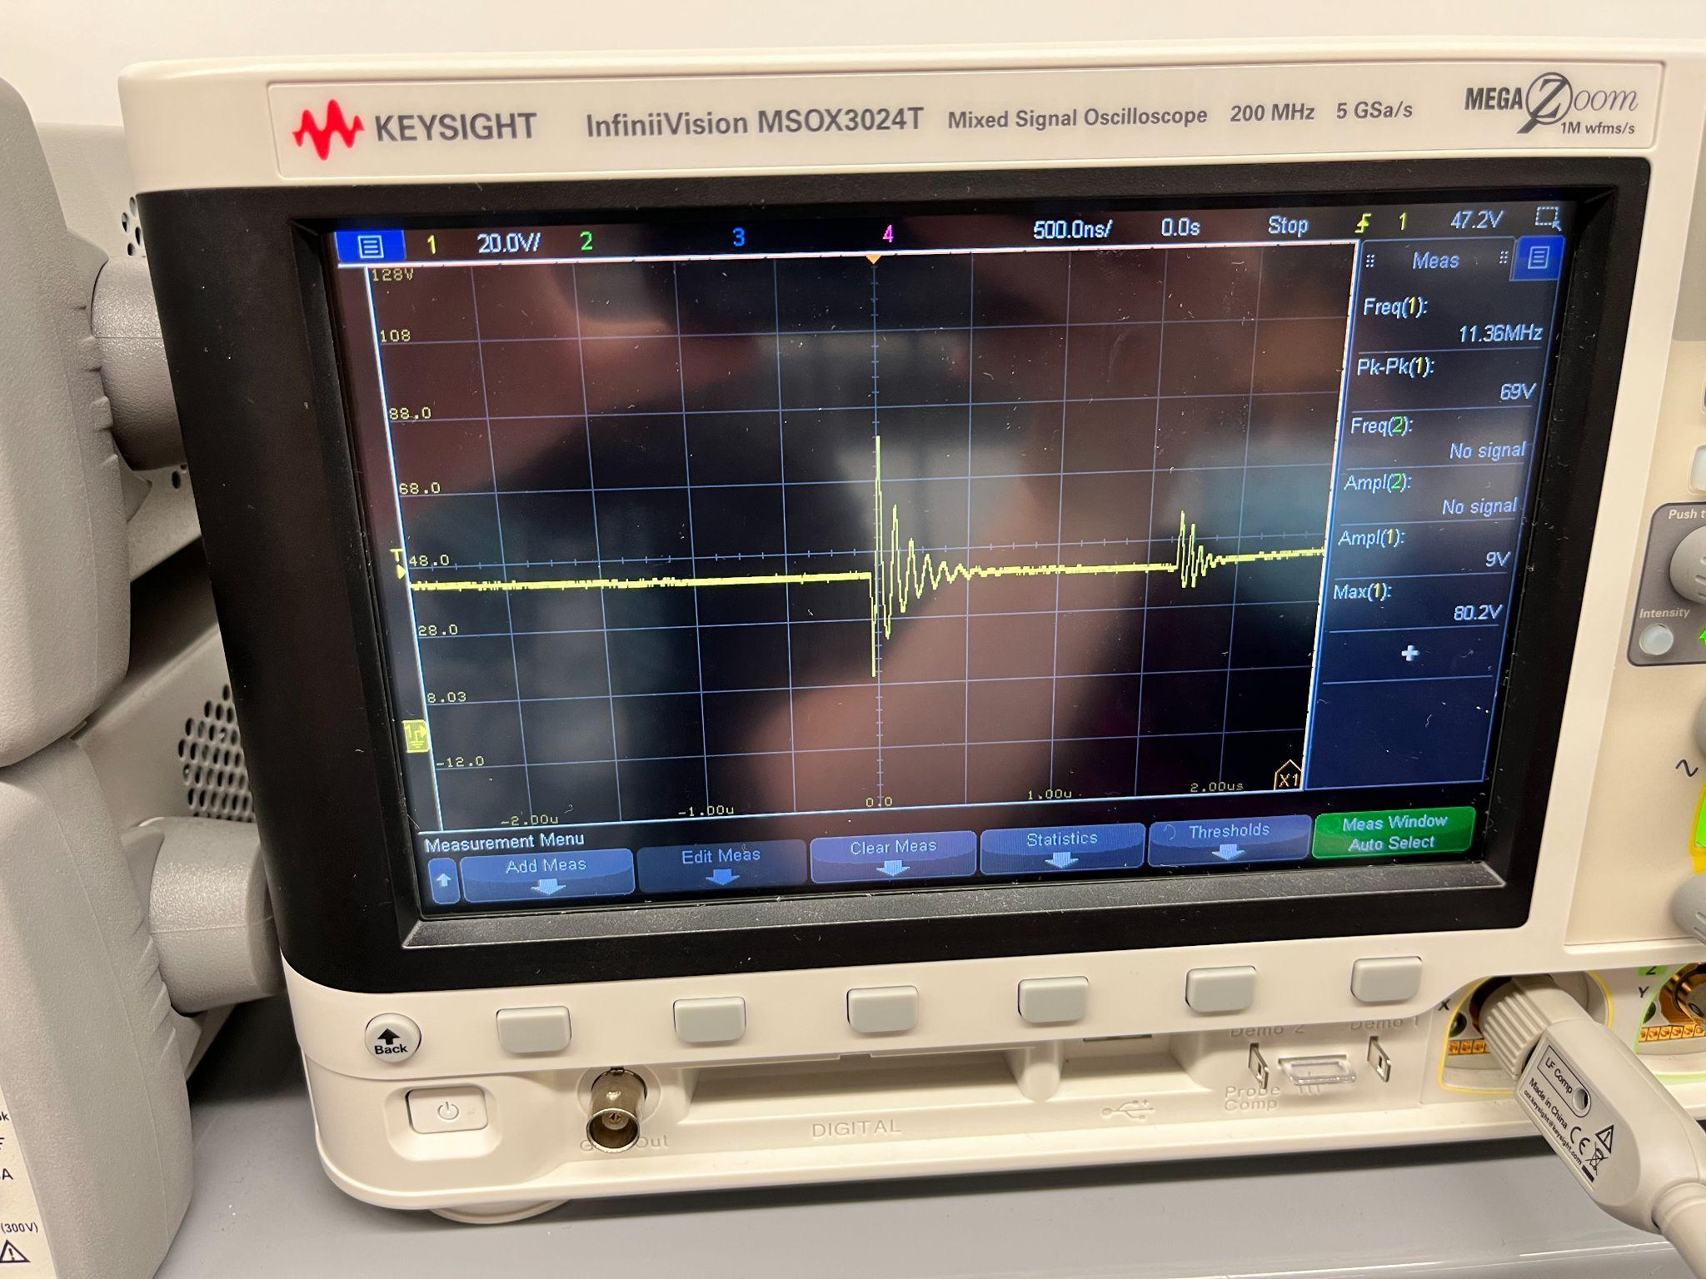

Input noise is an important factor in any power system, if the noise is large it may disrupt the power system and anything it powers.Because of this, the input noise was measured from the high current power supply.In this case, the noise was around or less than 3.5V. This value may be smaller due to my inaccuracy measuring the voltage.

***Figure 3.10: Input Noise***

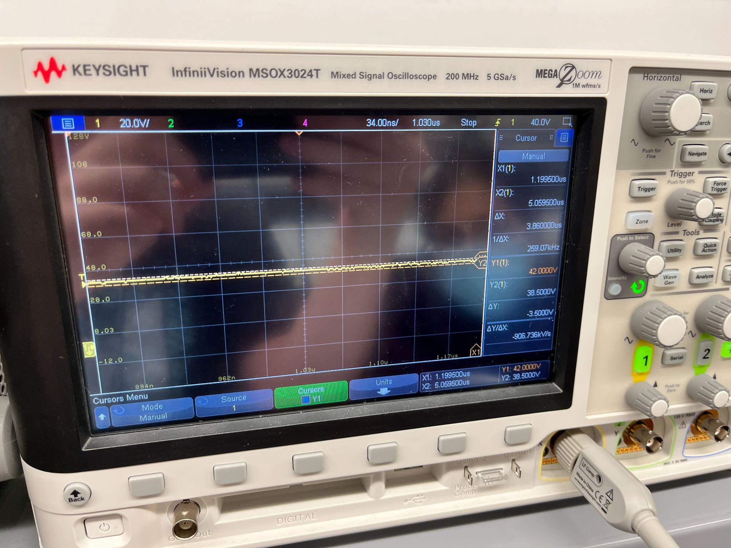

Below is the oscilloscope output voltage of the system. Measuring the output of the system ensures that there are no unexpected variations in the system. As seen in the power supply oscilloscope image previously, the wild swings seen below are caused by the power source itself and not the system.

***Figure 3.11: Output Voltage***

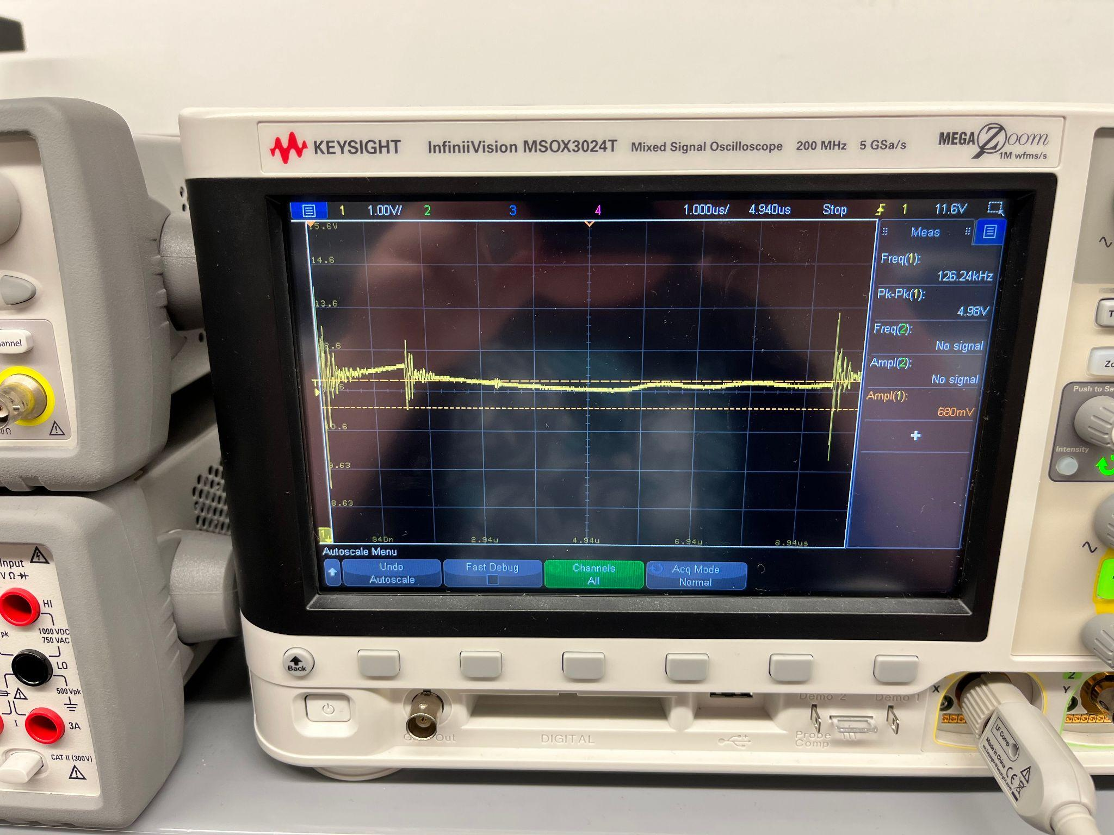

Lastly, output noise is also measured and documented. Comparing it to the input noise will tell someone how much noise is being generated by this specific subsystem. The Measured noise is around 300mV and comparing it

***Figure 3.12: Output Noise.***

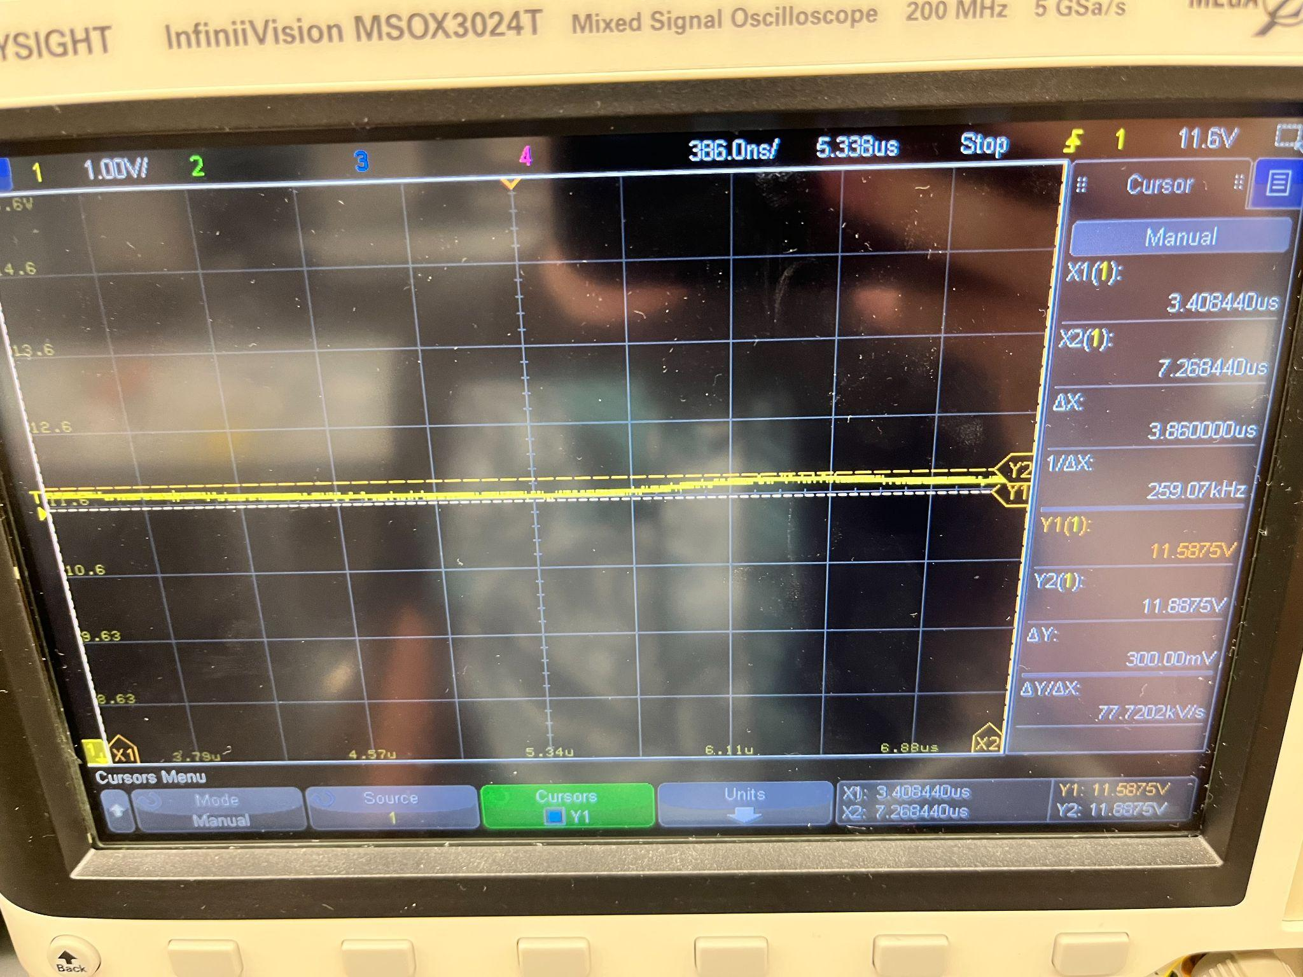

***3.4. Subsystem Diagnostic***

The DC-DC subsystem did encounter some issues during testing and validation. One problem that was encountered and quickly resolved was that the solar panel was not producing enough current for the system to work properly indoors. This seems obvious in retrospect, but the solar panel was producing 30-50V at the same time which led me to believe that enough current was supplied. This was quickly resolved by taking the solar panel outside and/or using the high current power supply in the FEDC.

The Most obvious one is that the feedback system does not change the output voltage at all. As the feedback voltage was varied from 1.3 to 4.7 volts there was almost no change in the output voltage. The probable solution to this problem will be mentioned in section 3.3.

The other problem came about in the load current testing. The subsystem worked as intended from 0 amp load current until 8 amp load current when suddenly I noticed one of my traces on my pcb was burning. This is why the Output voltage vs Output current test only ranges from 0A to 9A instead of the full load range of 20A as I was not able to test any higher. The proposed solution to this problem is mentioned below in the subsystem resolution/mitigation section. Other than these problems, the system works fully as intended.

***3.5. Subsystem Solutions***

For the feedback problem mentioned above, I believe that I need to switch the Rdac (the feedback resistor) for a lower resistance value. It is currently set at 100 ohms and the DAC input is only supplying 1.3 volts. In the case that switching the resistors is not sufficient, I will increase the feedback voltage to such that it will have an effect on the system. If this solution does not work, I will look into further solutions.

The burning trace problem is simple enough to fix. The next revision of the DC-DC converter PCB design will have a larger trace width to ensure that no feasible current encountered by the system will blow out a trace. I will also increase the size of other traces where this could be a future issue.

***3.6. Subsystem Conclusion***

Overall, while the system still has a few minor problems, it does successfully work as intended. The subsystem will take 20-60 volts DC power and convert it to 12V DC power up to 9 amps with reasonable efficiency. The only problems that arose are in the feedback system and in the trace widths of the PCB itself. The DC-DC converter is ready to power the other subsystems of this project despite these problems.

1. **DC-AC Inverter**

***4.1. Subsystem Introduction***

The DC-AC Inverter subsystem is designed to produce a pure sine wave AC output that is identical to the United States electrical grid. It is designed to successfully charge a cell phone and a laptop. It will be powered by the solar panel which feeds into the inverter subsystem via the DC-DC converter subsystem. The DC-AC inverter subsystem was tested to verify its reliability and efficiency, and that the output was identical to the electrical grid and capable of charging the targeted electrical devices.

***4.2. Subsystem Design***

The inverter subsystem will take in 12V DC and produce 165V AC peak-to-peak, capable of charging a cell phone and a laptop. It is made up of three main sections, the MCU, the H-bridge, and the transformer. The MCU will be programmed to produce PWM and act as inputs to the two MOSFET drivers which will then drive the H-bridge. The H-bridge will be connected to a step up transformer, stepping up the voltage to be able to output enough power to charge the necessary electrical devices. The schematic diagram designed through Altium is shown below.

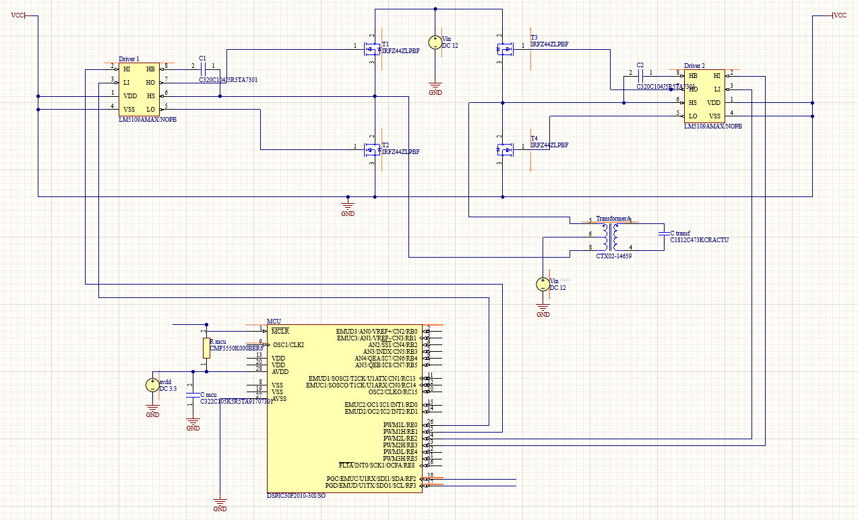

**Figure 4.1.** DC-AC Inverter Schematic

***4.2.1. Pulse Width Modulation***

The dsPIC30F2010 will be used in this subsystem to produce PWM. This MCU is a 16-bit digital signal controller produced by Microchip consisting of 28 pins, the chip pinout is included below.

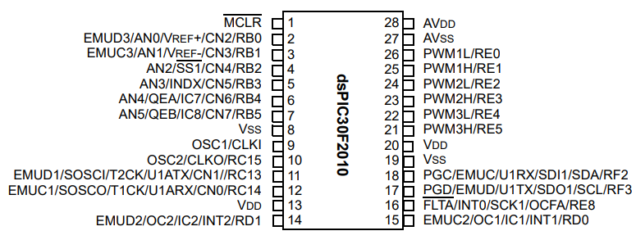

**Figure 4.2.** dsPIC30F2010 Pinout

For this subsystem, pins 23, 24, 25, and 26 (PWM2H, PWM2L, PWM1H, PWM1L) will be set as outputs, as they will hence act as inputs to the two MOSFET drivers as shown in **Figure 4.1**. The high outputs of the MCU will output square waves with changing duty cycles to resemble a pure sine wave. The low outputs will output the same waves as the high outputs, except shifted by 180 degrees, essentially creating an inversion of each other. Pins 27 and 28 (AVdd and AVss) will also be used for positive supply and ground reference, respectively.

MPLAB X IDE is used to code the MCU using C language, and a PICKIT3 will be used to program the chip.

A sine table made up of 512 values is constructed using excel to create the proper PWM needed to generate the final expected output of a pure sine wave. Below is a scatter plot of the sine table, showing a pure sine wave that goes from 0 to 65535 (max value) where the x-axis is the time step and the y-axis is the duty cycle.

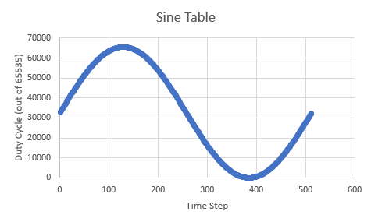

**Figure 4.3.** Sine Table Plot

A function ‘configure_pins’ is created to configure the MCU pins and PWM for free running mode. The PWM period was calculated as follows:

$PWM Period = Tcy *Prescale * PTPER$

where Tcy is the clock cycle set to 0.33ns, Prescale is set to 4, PTPER is the Time Base Period set to 7576, resulting in a PWM Period of 40us. From this, the PWM frequency was calculated using the following formula:

$PWM Frequency = 1/T$

where T is the PWM Period of 40us, resulting in a PWM frequency of 25kHz which is compatible with the selected MOSFET drivers for this subsystem.

This means that each pulse will be of 40us of different duty cycles, and after the 512 value square wave, total time will be 20ms which is a 50HZ required frequency of the sinusoidal PWM.

The output of this MCU shall be a square wave with increasing and decreasing duty cycles where, when plotted, the duty cycle shall resemble a sine wave as shown in **Figure 4.3**. The code used to generate the PWM for this subsystem is below.

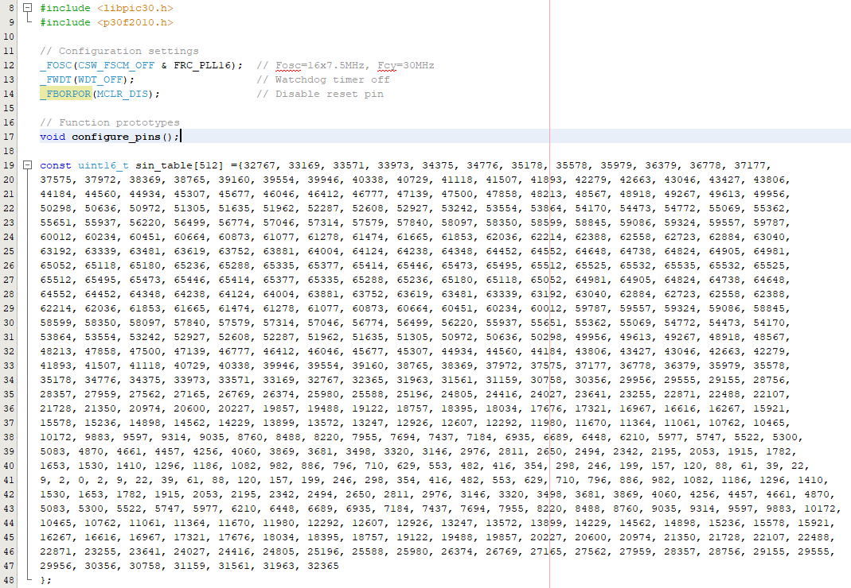

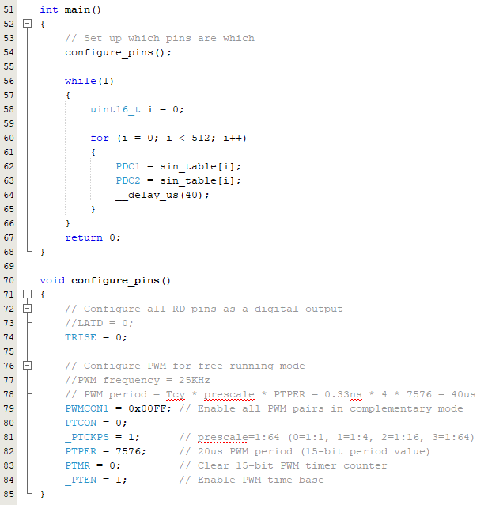

**Figure 4.4.** PWM Code

***4.2.2. H-Bridge***

A single phase H-bridge was designed using two MOSFET drivers and four PMOS MOSFETs. The LM5109AMAX/NOPB MOSFET drivers were selected for this subsystem and are compatible with the PWM frequency generated from the MCU. The high input and low input pins will take in square waves from the MCU as described in section **4.2.1.** These drivers will drive the gate driver of the power MOSFETs. The drivers are used because the PWM controller cannot produce the output current required to drive the gate.

The high outputs and low outputs of the drivers will be connected to the gate of the MOSFETs. The MOSFETs used in this subsystem will be the IRFZ44ZLPBF MOSFETs. This connection of the drivers and MOSFETs will essentially create the inverting mechanism that will result in the expected pure sine wave that will be identical to the electrical grid. The H-bridge section of the circuit is shown below.

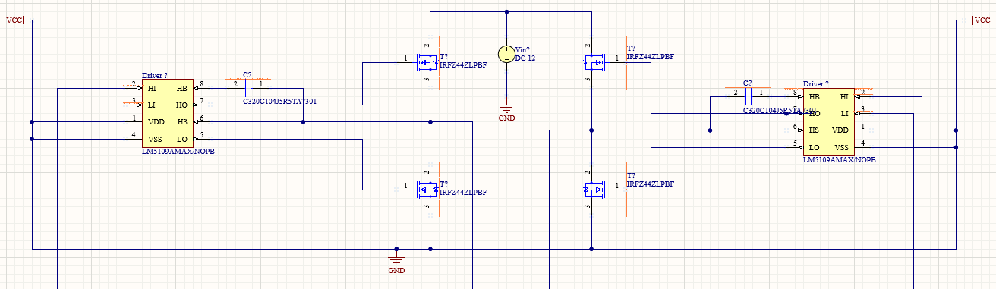

**Figure 4.5.** H-Bridge Schematic

***4.2.3. Transformer***

The output of the H-Bridge section will be connected to a step-up transformer which will step up the 12V AC to 165V AC peak-to-peak. A 1:14 transformer will be used for this system. Furthermore, a 47nF capacitor will be connected at the output of the transformer to cancel out any noise that is produced at the output.

***4.2.4. Simulation***

The circuit was simulated to see whether or not the inverter design would be successful. The circuit was not able to be simulated through Altium because no simulation designs could be found since specific parts were being used. Therefore, a basic circuit was created with NI Multisim that resembled the actual circuit built in Altium. The output was the expected pure sine wave as shown below.

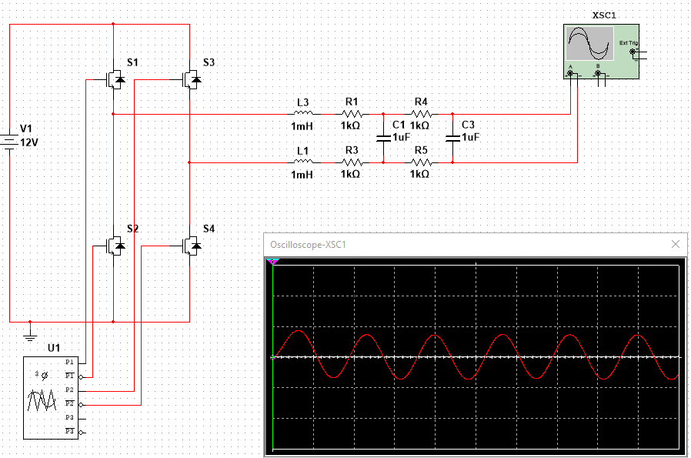

**Figure 4.6.** Multisim Simulation

***4.2.5. PCB Design***

The PCB design for this subsystem was designed using Altium designer and shown below. It consists of two layers, a bottom layer and a top layer, and a polygon pour was used to create the ground plane.

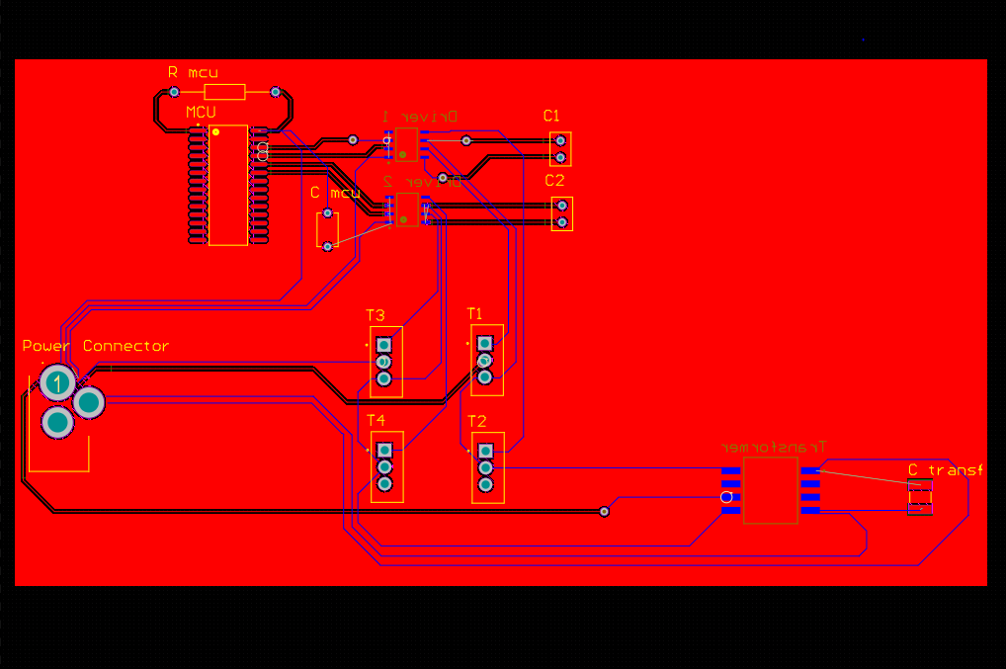

**Figure 4.7.** PCB Design

***4.3. Subsystem Validation***

The circuit was initially built and tested on a breadboard as shown in the figure below.

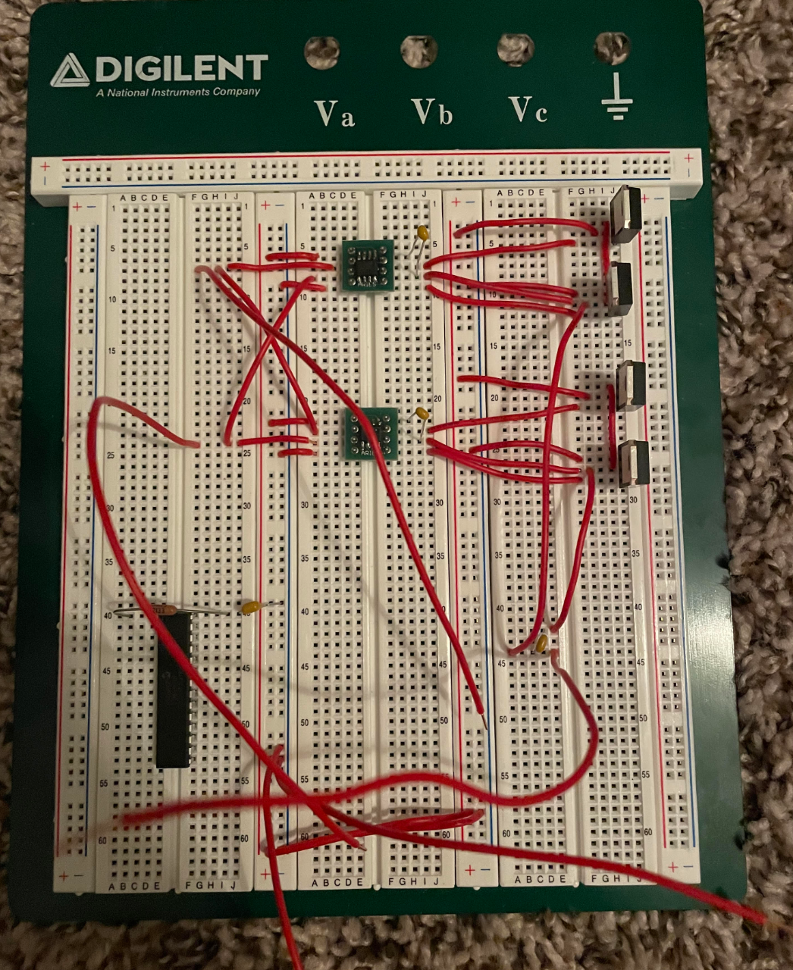

**Figure 4.8.** Inverter Breadboard

It was found that the microcontroller was not outputting anything that was expected so an Analog Discovery 2 was used as a wave generator to act as an input to the two MOSFET drivers. ‘Wavegen 1’ was used as the input for the high side input of the drivers, generating a square wave operating at 50Hz, a period of 20ms, a phase of 0 degrees, and an amplitude of 2V. Similarly, ‘Wavegen 2’ had the same configurations as ‘Wavegen 1’ except the phase was set to 180 degrees to act as the input to the low side input of the drivers.

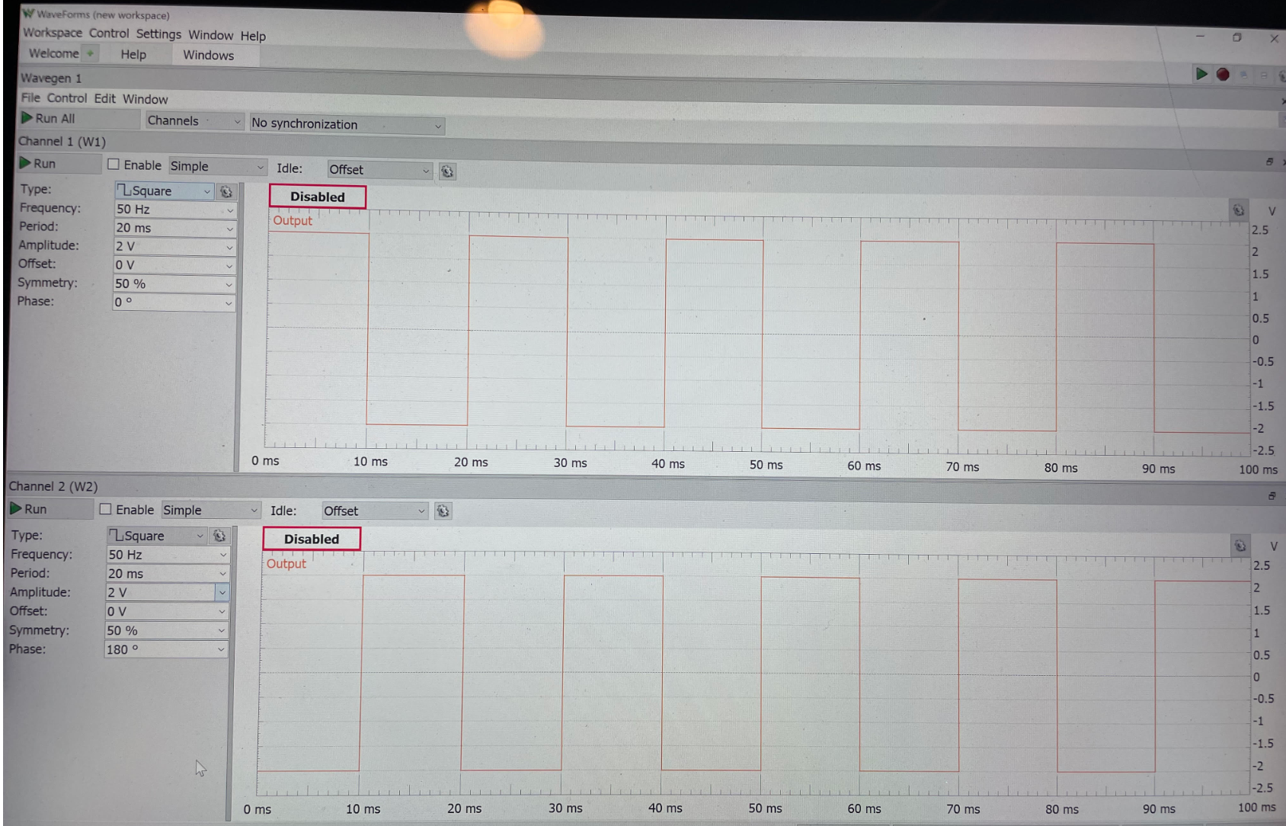

**Figure 4.9.** AD2 Wavegen Inputs

After using the AD2 as a wave generator, an output was finally achieved as shown below.

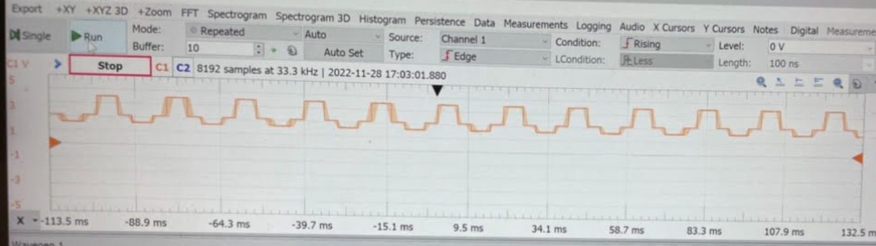

**Figure 4.10.** Circuit Output Test 1 using AD2

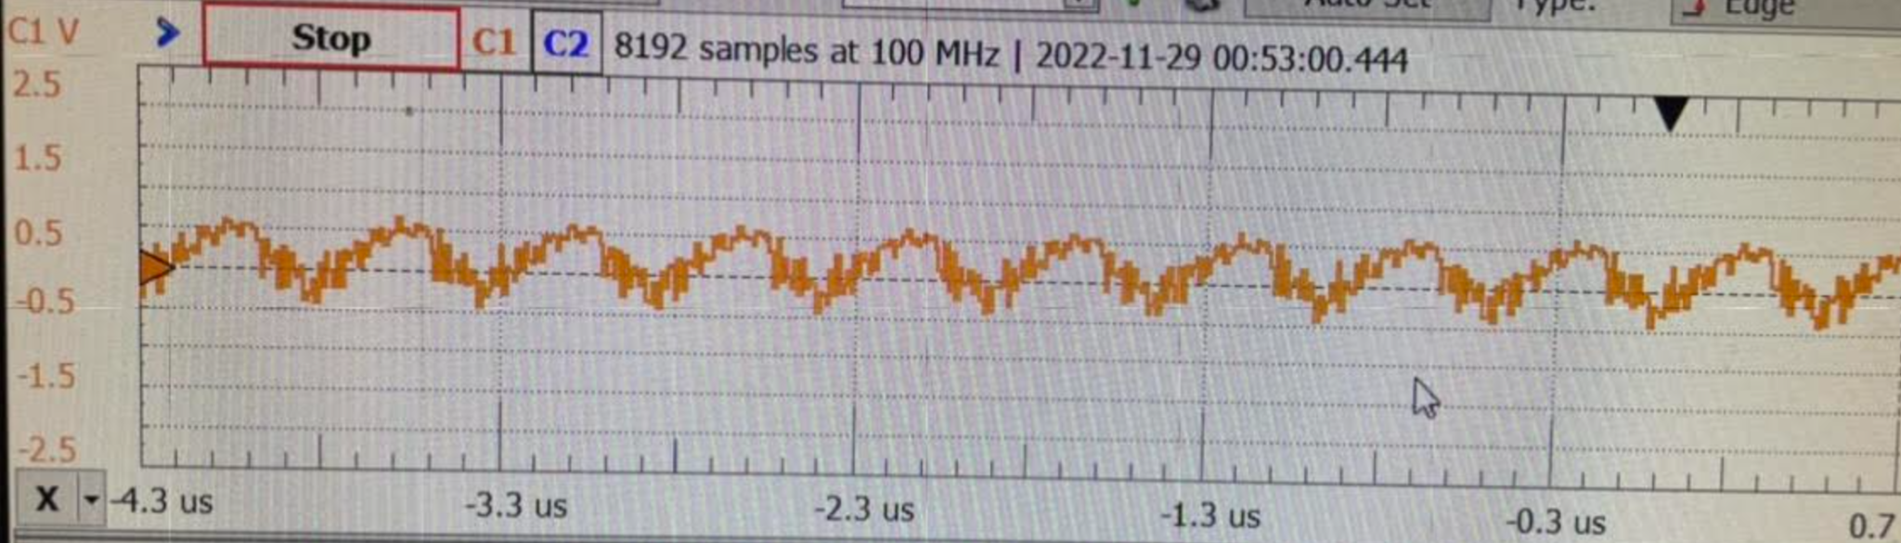

**Figure 4.11.** Circuit Output Test 2 using AD2

The outputs were not correct and did not resemble what was expected, likely due to connection issues and the use of a breadboard instead of a circuit board. Shortly after, no output was found and it was then found that the MOSFET drivers were not producing any output at all. Due to this, the circuit was then built on a PerfBoard as shown below.

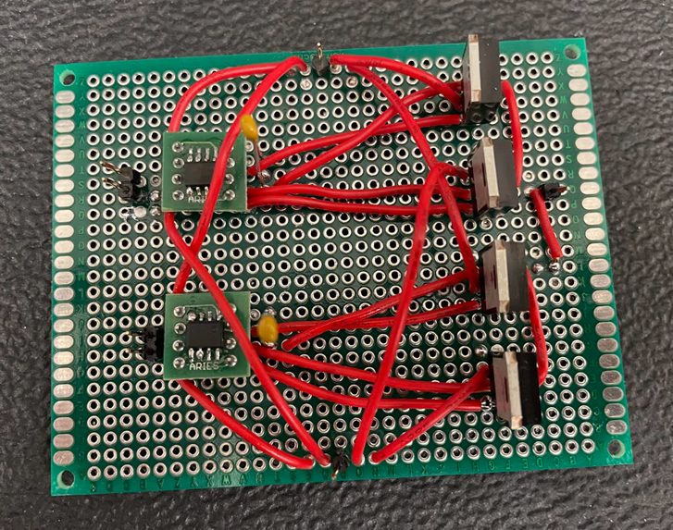

**Figure 4.12.** H-Bridge Built on PerfBoard

At this point of testing, the MCU code was updated and retested with the entire circuit with a 3.3V input powering the MCU, and a 12V input powering the H-Bridge as shown below.

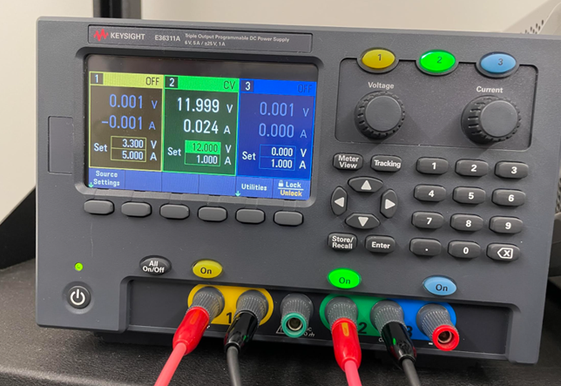

**Figure 4.13.** DC Power Supply

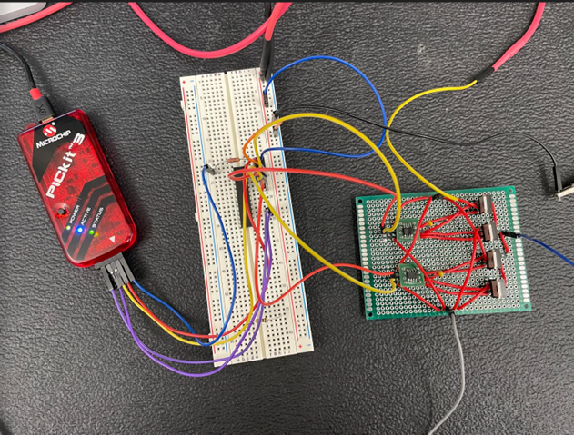

**Figure 4.14.** Inverter Circuit

Once again, the MCU was not able to output anything that was expected. The chip was successfully programed but when the MCU itself was tested and connected to the oscilloscope, no signal was able to be found.

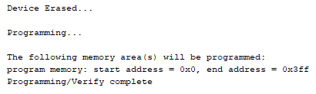

**Figure 4.15.** MPLAB Output

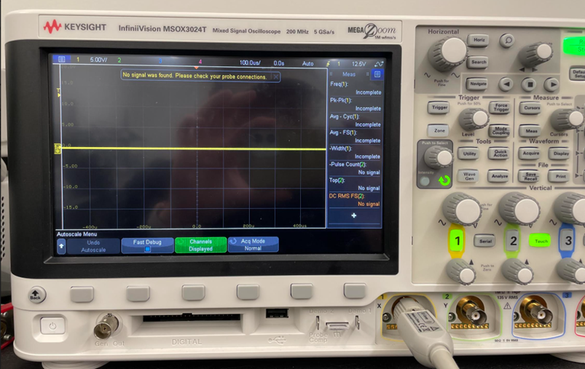

**Figure 4.16.** MCU Output from Oscilloscope

Therefore, an AD2 was connected to the circuit to act as inputs to the MOSFET drivers, using the same configurations as before. The results are shown below.

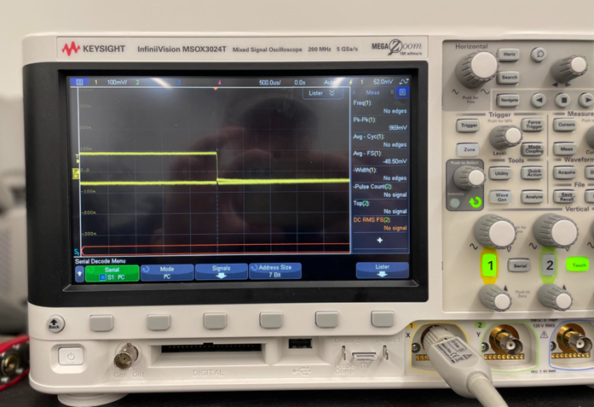

**Figure 4.17.** Inverter Oscilloscope Output Test 1 using AD2

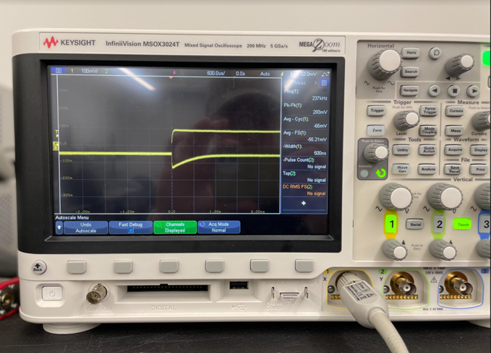

**Figure 4.18.** Inverter Oscilloscope Output Test 2 using AD2

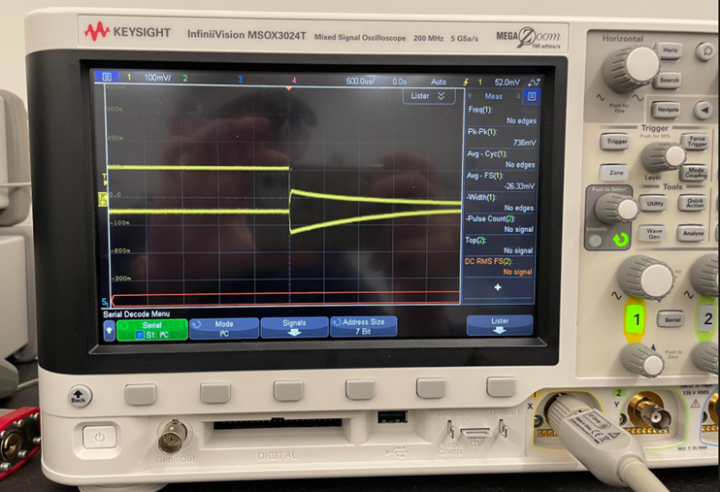

**Figure 4.19.** Inverter Oscilloscope Output Test 3 using AD2

Once again, the outputs were not correct and the circuit did not behave as expected.

***4.3. Subsystem Diagnostic***

The DC-AC Inverter subsystem was not able to successfully output a pure AC sine wave largely due to two main factors, error in the MCU code and a damaged MOSFET driver.

The MCU was not able to produce any output but it was able to be successfully programmed as indicated in **Figure 4.15**. There are probably multiple reasons for this. First being that there is still an issue within the code that is being overlooked. Second, there could be some type of configuration issue that I am still not aware of but I am actively trying to figure it out.

Regarding the H-bridge of the circuit, through testing and debugging, it was found that the issue largely still lies within the MOSFET drivers as they are still not outputting what is expected. When using the multimeter at the outputs of the MOSFET drivers to check if the pulses coming from the wave generator were accurate, the voltage was constant and there was no fluctuation. When the drivers were hooked up to the oscilloscope, the output signal was not implementing the proper delay as indicated in the MOSFET driver datasheet as shown below.

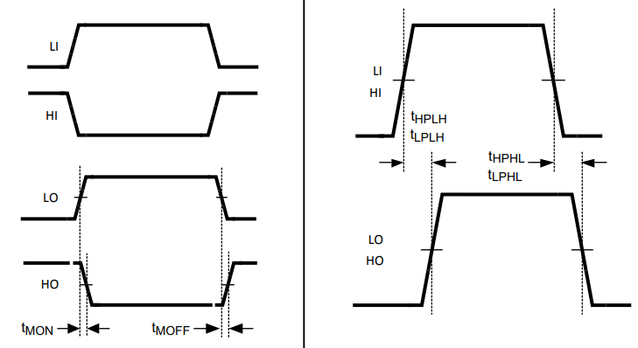

**Figure 4.20.** Timing Diagram from MOSFET Driver datasheet

This could largely be due to the fact that the MOSFET drivers were damaged in some way or there is an error in the connections of the circuit.

***4.3. Subsystem Resolution/Mitigation***

The MCU code is still currently being tested and updated. The goal is to output the proper PWM that will, in the end, produce the proper pure sine wave that is expected of the entire circuit. I have personally bought a PICKIT 3 to keep testing and debugging for the rest of the semester and throughout the winter break so that I do not need to rely on going into the FEDC. I am still currently working on debugging the code and figuring out why the output is not what is expected of it.

Regarding the H-bridge, more MOSFET drivers are being ordered to verify whether or not the H-bridge is malfunctioning due to a damaged MOSFET driver. The entire circuit will be tested again and the connections are also being verified to ensure that all connections on the PerfBoard accurately match that of the circuit schematic.

***4.3. Subsystem Conclusion***

The DC-AC Inverter subsystem was designed to take in 12V DC, convert it to 12V AC that is identical to the United States electrical grid, and stepped up by a step-up transformer to successfully charge a phone and a laptop. It was designed using a MCU to provide PWM, an H-Bridge design for the inverting mechanism, and a step-up transformer to output the intended power needed.

Though the inverter was successfully designed and simulated, there were many problems while actually testing the built circuit in the lab. During testing in the lab, the DC-AC Inverter did not behave as expected, largely due to problems within the MCU code and problems with the current MOSFET drivers. Therefore, the inverter was not able to successfully output a pure sine wave that was expected of it, though testing is still being carried out.

1. **Android Application and Website**

***5.1. Subsystem Introduction***

The Android Application and Website subsystem is designed to provide the user with information on the solar panel battery system that could be used for maintenance and analysis. This system was made using Ionic with Angular allowing for both the website and application to be designed concurrently. Both applications also use a backend database, firebase, to send and receive data that the user needs about their system. The data that is received by both applications is the power, current, voltage, battery level, and if a device is connected to the AC or DC connections. The power is displayed in a graph, showing real time data from that current day depending on the harnessing of the system. This data also is being tracked on a weekly and monthly basis. To provide security for the user, an authentication page is implemented on both applications forcing the user to be validated in order to access specific user data.

It should be noted that there are no code snippets inside this report. All code is shown in our TAMU repository for this project:

<https://github.com/llugo15/solar_power_battery/tree/nateg580-patch-1>

***5.2. Subsystem Design***

At a high level, the design of this subsystem was for both applications to send and extract data from the backend database in the most efficient manner. To accomplish this, the backend database had to be structured so that data that comes in is set into categories, making it easier for the frontend (what is seen by the user) to retrieve data. To organize data in the backend in categories, a tree was used. At the highest level of the tree is the description of the data that shall be extracted, for example, solar panel data (power, current, voltage), AC data, battery level, etc. Inside the tree is the data that shall be specifically pulled, such as the power or the current. This design is shown in **Figure 5.1.**

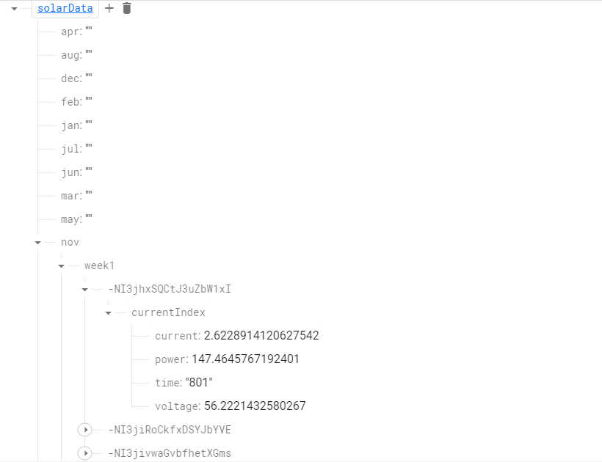

***Figure 5.1.*** *Tree Structure Used in Firebase Database*

At a lower level, the design of both applications differed. A beginning template is shown in **Figure 5.2** for the initial website design, and **Figure 5.3** for the initial android application**.**

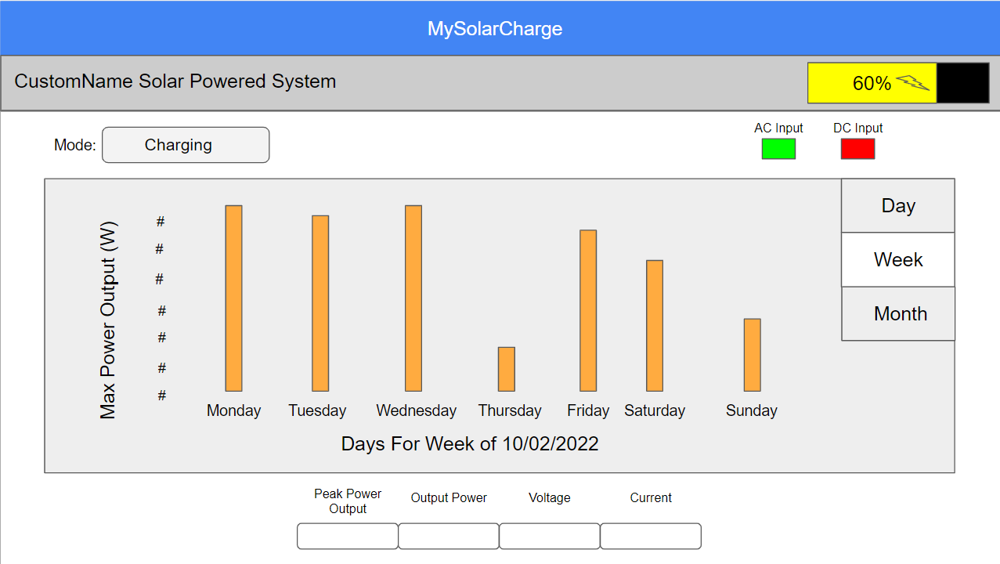

***Figure 5.2.*** *Initial Design of Website Application*

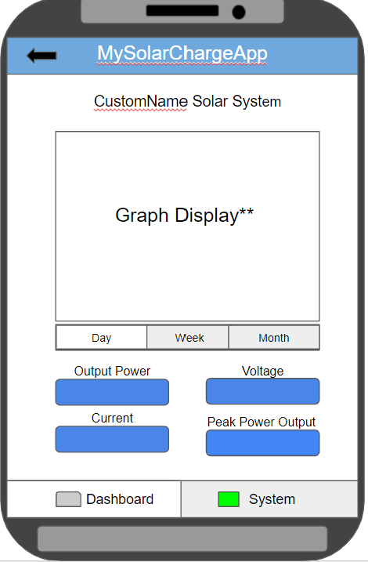

***Figure 5.3.*** *Initial Design of Android Application*

The website application was made using only one page. This means there are no other pages or tabs that can be accessed on the website other than the authentication page. All the data is then displayed on this page, giving the user the ability to change the graph views to see the weekly and monthly data. The reason for this design approach was to give the user easy access to all the data without having to separate it on multiple pages. Additionally, there was not enough data that could be used for another page. As for the android application, the design was to have the daily graph data on the first page so the user knows instantly how their system is performing in real time. There is then another page that the user can access to look at the weekly and monthly data. This is to add separation and decrease the clutter of data that is displayed to the user since a phone has a smaller screen size then a laptop or desktop. Hence the need for two different designs which make both applications more user friendly. It should be noted that both applications display the same data to the user. At the top of both applications is the app name and the ability to name the system that the application is connected to. Under that displays the battery level, if the battery is charging or discharging, and which of the two outputs (AC or DC) is connected and charging a device. Then a graph is displayed, showing the power data for that day, with an option to view the weekly and monthly data, which are accessed differently depending on the device that is being used. Lastly, numbers for the power, current, and voltage for the internal system is displayed for the user to gauge how the system is performing. The final design is shown in **Figure 5.4** for the Website Application and **Figure 5.5** for the Android Application.

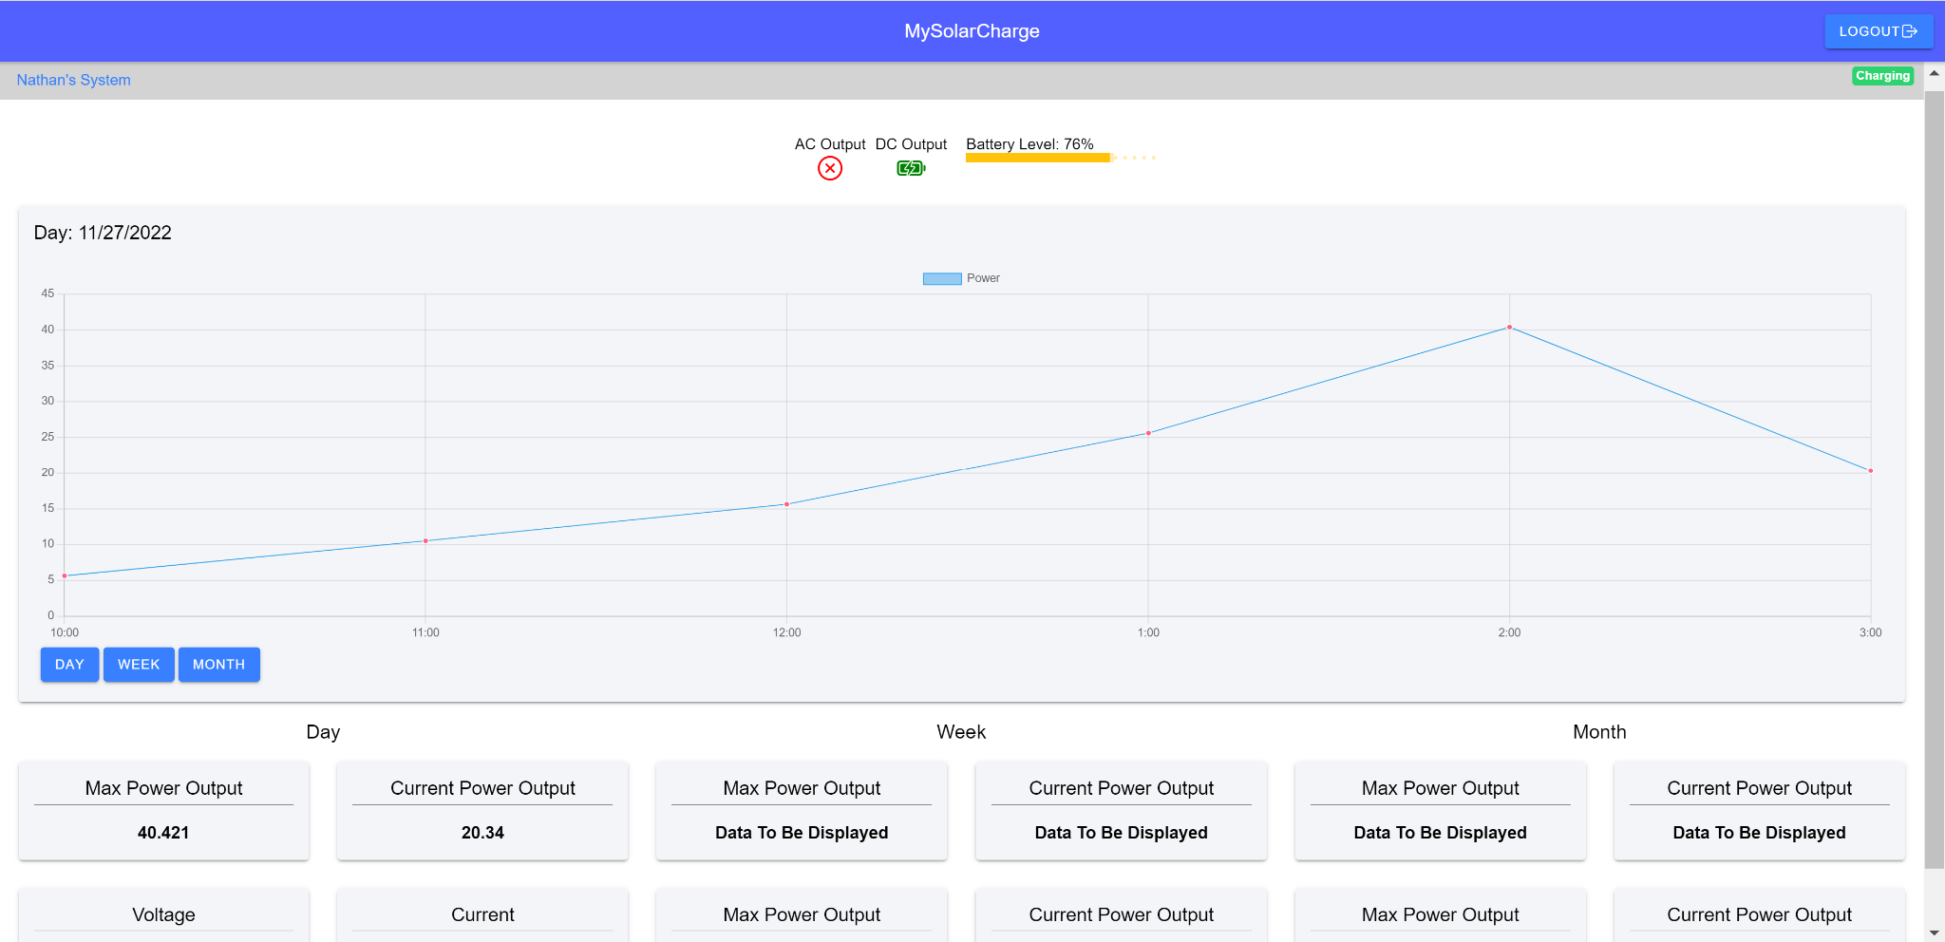

***Figure 5.4.*** *Final Design of Website Application*

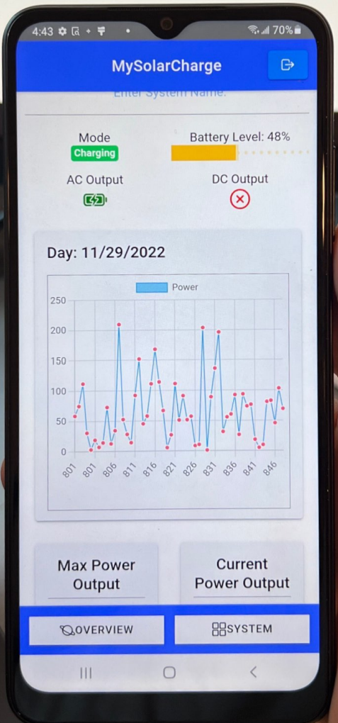

***Figure 5.5.*** *Final Design of Android Application*

***5.3. Subsystem Validation***

Note: In the validation section of this report dummy data was used. Throughout the report this data may be referred to as internal system data.

***5.3.1. Data Output***

This subsystem needs to receive data from the backend database in order to display it to the user. To validate this test, a service file was created inside the project files. The purpose of a service is to be able to be accessed from anywhere within the coding project. The service was used to get data from the backend database so that it can be accessed from anywhere within the project. To test this, this service was connected to the backend, then functions were written to access the nodes within the tree data structure. Inside the functions were written tests that output onto the applications console, which can be accessed by inspecting any page. Below is the result of this test.

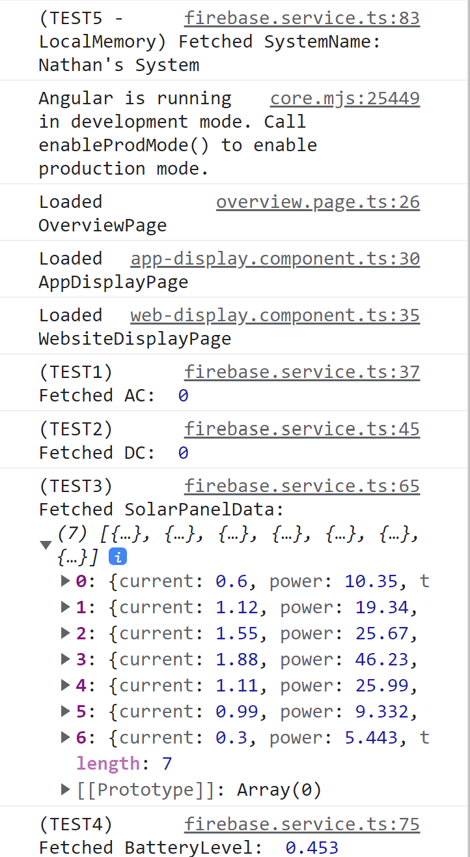

***Figure 5.6.*** *Applications Receiving Data from Firebase Database*

***5.3.2. Diagnostic Output***

This subsystem needs to receive data from the backend database dynamically for the graphs and data displayed to the user updates in real time. To test this, one test case was written that executes each time new data enters the application from the database. As shown in the figure, this test case is TEST4, fetching the current battery level.

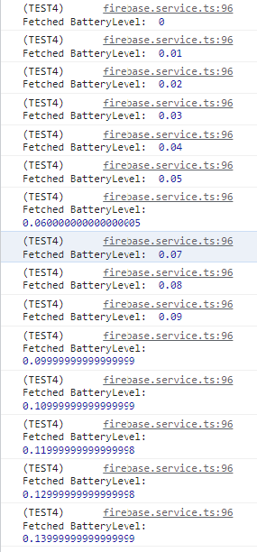

***Figure 5.7.*** *Applications Receiving Data from Firebase Database Dynamically*

***5.3.3. Database Operations***

This subsystem shall accurately send and receive data from the database. To ensure this, a tree structure was used for the database to organize data so the applications know where to pull data from depending on the day, week, or month. To test this, data was sent from the applications through another service. This service acted as the ESP32 and used dummy data to see if the database updates dynamically and is reflected on both applications. The send data is shown in a test in the figure below.

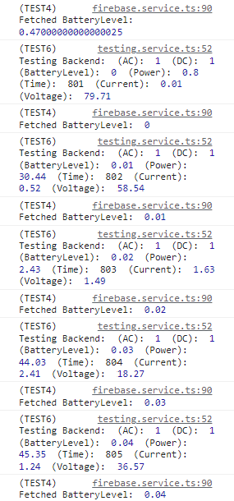

***Figure 5.7.*** *Testing Database from Applications*

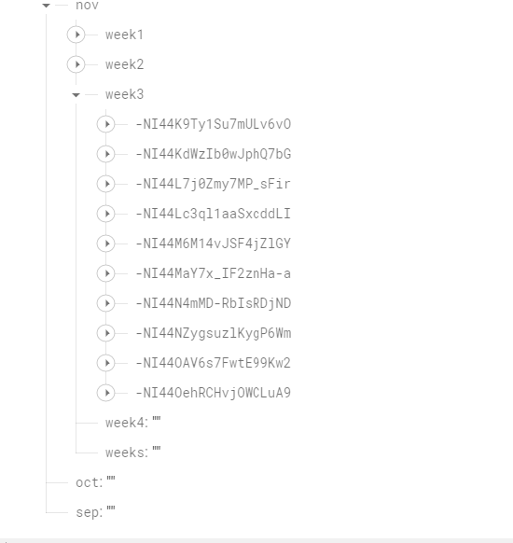

***Figure 5.8.*** *Database Receiving Data from Applications*

***5.3.4. System Display of Crucial Data***

This subsystem shall receive data dynamically from the database and display it accurately for the user. This test is a visual test. Both applications shall display data in a graph format and directly for the user. This data shall also change depending on the new data that is sent to the database. **Figure 5.5** shows an accurate representation of this test case. Data is being displayed for the user in a graph format and is shown to be changing dynamically.

***5.3.5. User Authentication***

This subsystem includes a user authentication page. The authentication page gives the user the ability to sign up a new account along with signing into an existing account. Signing up for an account is allowed as long as the password is above six characters and there is not a current user that has the same email address as the one being used to sign up. These validation tests are shown in **Figure 5.9 and 5.10** respectively.

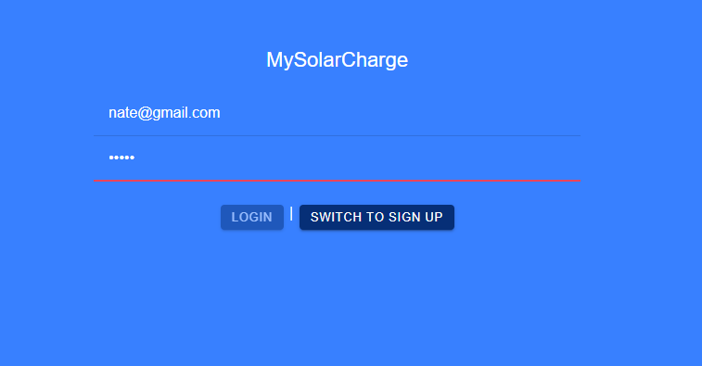

***Figure 5.9.*** *Authentication Page Showing Minimum Six Character Password Limit*

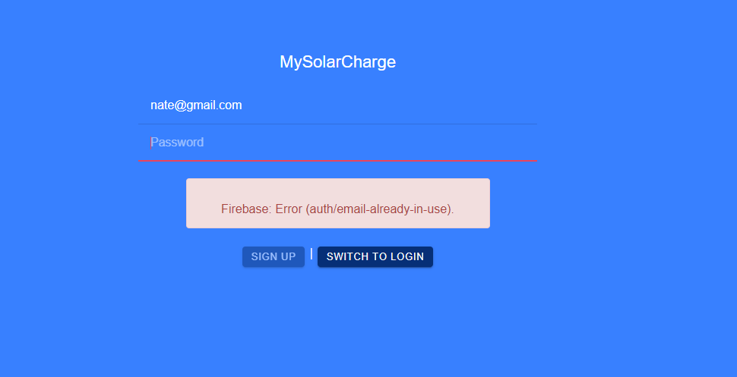

***Figure 5.10.*** *Authentication Page Showing Existing User Email Error*

***5.3.6. Existing User Authentication***

This subsystem includes a user authentication page. The validation for signing into an existing account is the correct password and checking if a user has an existing account, these validations are shown in **Figure 5.11 and 5.12** respectively.

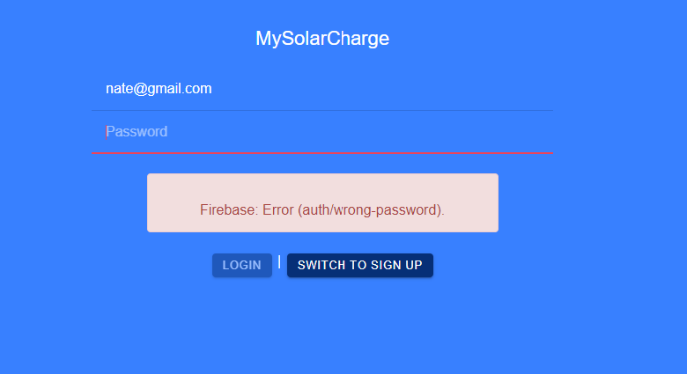

***Figure 5.11.*** *Authentication Page Showing Incorrect Password Error*

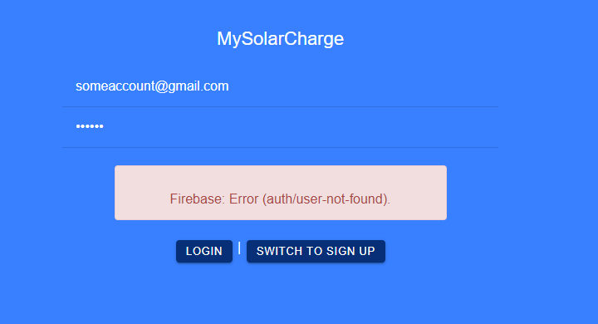

***Figure 5.12.*** *Authentication Page Showing User Not Found Error*

***5.4. Subsystem Diagnostic***

This subsystem checked off all the validation and execution planning that was set forth. The system successfully completed the final demo and displayed all the data that was described above accurately and efficiently for the user. This subsystem is completely set up in regards to sending data to the database, receiving that same data in both applications, and displaying the data for the user.

What needs to be done is connecting the database to the ESP32 for accurate testing of the solar battery system. Once this is completed, the weekly and monthly graph and data needs to be updated. Currently it works off of the daily dummy data from within the application. What it needs to be restructured to pull data directly from the database. The reason and solution for this is discussed in **5.5**.

***5.5. Subsystem Diagnostic Solution***

Currently the weekly and monthly data is being pulled from within the application. It does this by funneling the data that is used for the daily graph and extracting the average from this data. The disadvantage of this is that monthly and weekly data from that user is not stored on the database, meaning that it is accessible to anyone in the front-end (what the user can see) and also decreases the performance of the application. To solve this, restructuring of the database tree shall be done. A week and month tree branch shall be created to store averages and maximum of the daily data that is currently in the database. This will increase the applications performance due to less processing of data along with organizing the data more efficiently. This is crucial because there can be multiple users at a time. If this measure is not taken into account, once multiple users are on the applications, their data will get intertwined with other users, displaying false information and possibly breaking the application due to processing of large amounts of data.

***5.6. Subsystem Conclusion***

Although there are still some minor changes that need to be made to the structure of the application and the database, both are working as intended. The goal this semester was to successfully make both a website application and android application. To do this, a database was needed, especially with the amount of data our system is going to produce. This was successfully incorporated into the project and has been validated. The objective of the applications is to show the user data that could be used for general maintenance and knowledge. By displaying the power, current, voltage, battery level, and outputs onto the applications the user is provided with all the information needed for maintenance and knowledge of their system performance.